Thermal Radiation Worksheet
This worksheet accompanies slide 14 of Thermal Radiation.ppt

1. Design an experiment to investigate how different surfaces absorb infrared radiation. Choose from the equipment listed and sketch the experiment layout in the
space below.

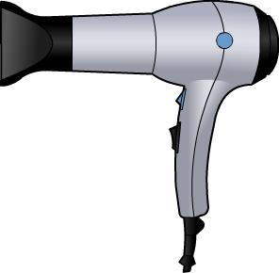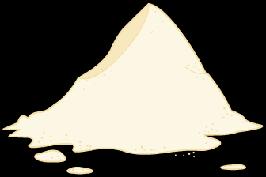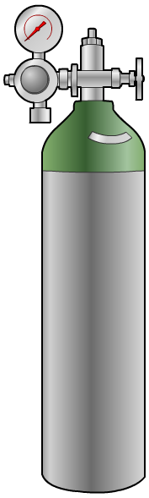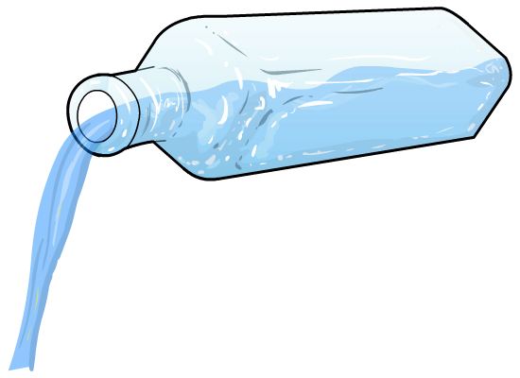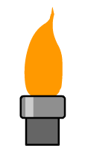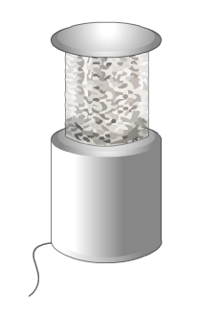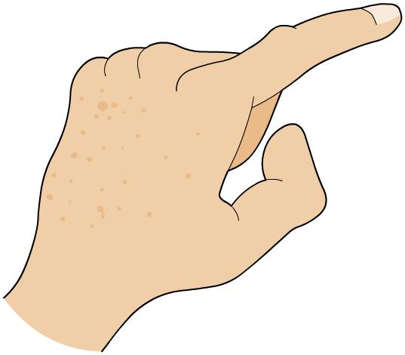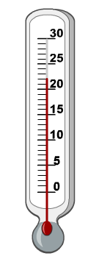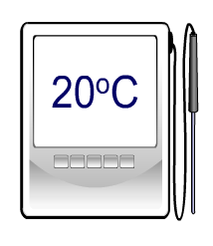
hot air
blower
powdered
milk
air
water
test tube
glass beaker
Bunsen
burner
infrared
heater
hand
thermometer
thermocouple
plastic
beaker
different
coloured
surfaces
different
insulating
surfaces

- What are the independent and dependent variables in your experiment?

………………………………………………………………………………………………………………
………………………………………………………………………………………………………………
………………………………………………………………………………………………………………
………………………………………………………………………………………………………………

- How would you make your results valid and reliable?

………………………………………………………………………………………………………………
………………………………………………………………………………………………………………
………………………………………………………………………………………………………………
………………………………………………………………………………………………………………

- Write a method explaining how you would carry out your experiment.
Your target audience is an average Year 9 student, so you will need to write it in appropriate language.

………………………………………………………………………………………………………………
………………………………………………………………………………………………………………
………………………………………………………………………………………………………………
………………………………………………………………………………………………………………
………………………………………………………………………………………………………………
………………………………………………………………………………………………………………
………………………………………………………………………………………………………………
………………………………………………………………………………………………………………
………………………………………………………………………………………………………………
………………………………………………………………………………………………………………

