The Universe Worksheet
This worksheet accompanies slide 6 of The Universe.ppt

As astronomers have observed more about the Universe, models of its shape and size have changed.

1a. Label the models of the Universe shown below with the following words: Sun (×2),
Moon, Earth and stars. Which of the models is the Copernican model, and which is the Ptolemaic model?

………………

………………

………………

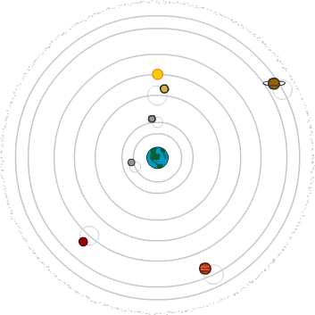
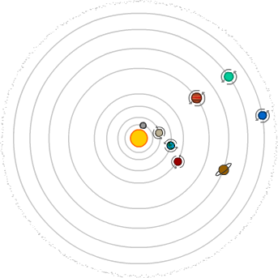

………………
………………

The …………………… model

The …………………… model

b. What are the main differences between the Ptolemaic and Copernican models?

……………………………………………………………………………………………………………
……………………………………………………………………………………………………………
……………………………………………………………………………………………………………
……………………………………………………………………………………………………………
……………………………………………………………………………………………………………
……………………………………………………………………………………………………………
2. Describe the problems with the Ptolemaic model of the Universe that prompted Copernicus to develop his own model.

………………………………………………………………………………………………………………
………………………………………………………………………………………………………………
………………………………………………………………………………………………………………
………………………………………………………………………………………………………………
………………………………………………………………………………………………………………

3. List one observation made by Galileo that supported Copernicus’s model of the Universe.

………………………………………………………………………………………………………………
………………………………………………………………………………………………………………
………………………………………………………………………………………………………………
………………………………………………………………………………………………………………
………………………………………………………………………………………………………………

4. Why do you think that the Copernican model of the Universe was considered so controversial when it was first published?

………………………………………………………………………………………………………………
………………………………………………………………………………………………………………
………………………………………………………………………………………………………………
………………………………………………………………………………………………………………
………………………………………………………………………………………………………………
………………………………………………………………………………………………………………
………………………………………………………………………………………………………………
………………………………………………………………………………………………………………

