The Origin of the Universe Worksheet
This worksheet accompanies slide 7 of The Origin of the Universe.ppt

In the early 20th century, Edwin Hubble made two very important observations about the Universe. He found that:
- most of the light from distant galaxies is shifted towards the red end of the visible spectrum
- the further away a galaxy is, the more its light is redshifted.

These discoveries led Hubble to conclude that most galaxies are moving away from our own, and that the further away a galaxy is, the faster it is moving away – the Universe is expanding.

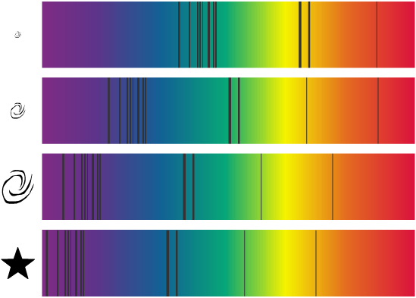
1. The diagrams below show the light spectra of the Sun and three other celestial objects.
OBJECT 4
OBJECT 3
OBJECT 2
THE SUN
RED

a. Which object is travelling the fastest?
……………………………………………………………………………………………………………
b. Which object is furthest away?
……………………………………………………………………………………………………………
2. Give two pieces of evidence that support the Big Bang theory.

………………………………………………………………………………………………………………
………………………………………………………………………………………………………………
………………………………………………………………………………………………………………
………………………………………………………………………………………………………………
3. What is the Steady State theory?

………………………………………………………………………………………………………………
………………………………………………………………………………………………………………
………………………………………………………………………………………………………………
………………………………………………………………………………………………………………
………………………………………………………………………………………………………………
………………………………………………………………………………………………………………
………………………………………………………………………………………………………………
………………………………………………………………………………………………………………
4. Explain how the Sun and the Earth were formed in the early Universe.

………………………………………………………………………………………………………………
………………………………………………………………………………………………………………
………………………………………………………………………………………………………………
………………………………………………………………………………………………………………
………………………………………………………………………………………………………………
………………………………………………………………………………………………………………
………………………………………………………………………………………………………………
………………………………………………………………………………………………………………
………………………………………………………………………………………………………………

