Static Electricity Worksheet
This worksheet accompanies Static Electricity.ppt and Effects of Static Electricity.ppt

1a. Friction can be used to create a static charge. Explain what happens when two
insulating materials are rubbed together. Include the terms: positive, negative, transfer, electron, and charge.

……………………………………………………………………………………………………………………………………………………………………………………………………………………………………………………………………………………………………………………………………………………………………………………………………………………………………………………………………………………………………………………………………………………

b. Describe the difference in the number of electrons between the insulating material that is left negatively-charged and the material that is positively-charged.

……………………………………………………………………………………………………………………………………………………………………………………………………………………………………………………………………………………………………………………………………………………………………………………………………………………………………………………………………………………………………………………………………………………


c. What are atoms that have lost or gained electrons known as?

………………………………………………………

2a. When two electrically-charged objects are brought together they exert a force on each other. What would happen to the charged rods below if they were moved closer together?

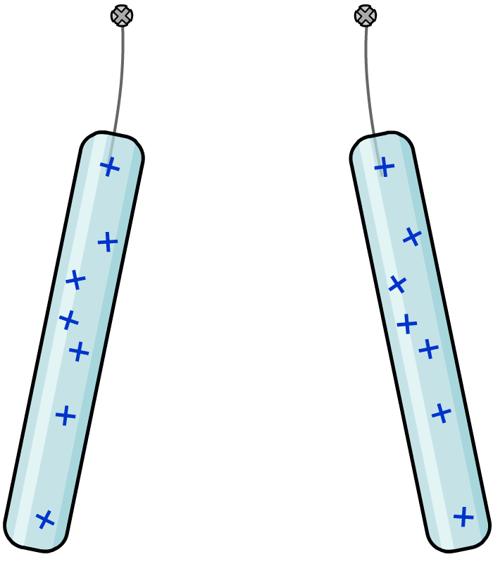
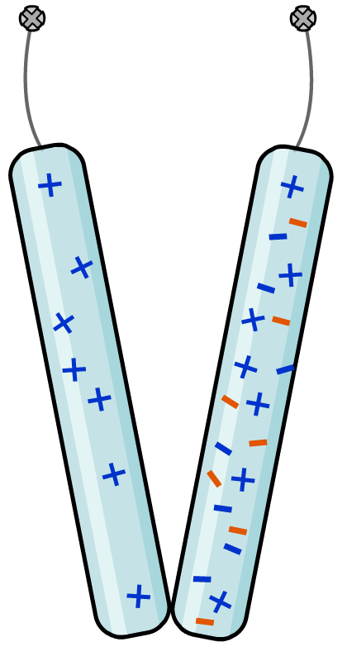
acetate rod

polythene rod

………………………………………………………………………………………………………………………………………………………………………………………………………………………………………………………………………………………………………………………

b. Fill in the gaps.
Two objects that have the same type of charge ………………… each other.
Two objects that have opposite types of charge ………………… each other.

c. Explain why rubbing a balloon on your jumper will enable you to stick it to the wall.

………………………………………………………………………………………………
…….…………………………………………………………………………………………
…………………….…………………………………………………………………………
…………………………………….…………………………………………………………
………………………………………………………………………………………………
3. Give two examples of how static electricity can cause problems in everyday life.

……………………………………………………………………………………………………..……
………………………………………………………………………………………………………..…

4. Give one example of how static energy can be used to benefit humans.

………………………………………………………………………………………………………..…

5. Electrostatics can also be useful for spray-painting a car. Explain how the negatively-charged spray gun and the positively-charged car ensures that the car is given a complete and even coat of paint with no drips or waste.

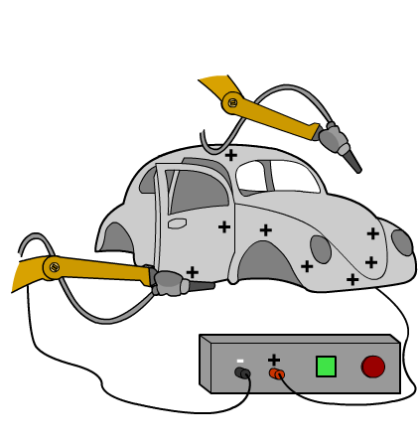
………………………………………………………………………………………………………………………………………………………………………………………………………………………………………………………………………………………………………………………………………………………………………………………………………………………………………………………………………………………………………………………………………………………………………………………………………………………………………………………………………………………………………………………………………
…………………………………………………
………………………………………………
……………………………………………
…………………………………………
6. Fill in the gaps using the words below.

a. A ………………… object can be negatively- or positively- charged.
b. ………………… charged objects have gained electrons. ………………… charged objects have lost electrons.
c. When an object is connected to the …………………, electrons flow between the object and the ground, ………………… the charges. This provides protection against electrical shock.
d. Electrons will flow ………………… a positively-charged object and ………………… a negatively-charged object.

negatively | out of | positively | charged | earth
evening out | increasing | neutrally | into | around

7. Explain why workers in some jobs wear special insulating anti-static shoes and how the shoes work to their advantage.

…………………………………………………………………………………………………………………………………………………………………………………………………………………………………………………………………………………………………………………………………………………………………………………………………………………………………………………………………………………………………………………………………………………………………………………………………………………………………………………………………………………………………………………………………………………………………………………………………………………………………………………………………………………………………………

