Stars Worksheet
This worksheet accompanies slide 19 of Stars.ppt

Complete the flow chart to show what happens to stars at each stage of their life.

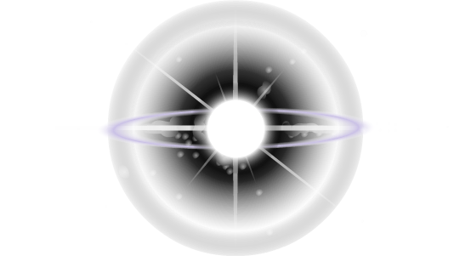

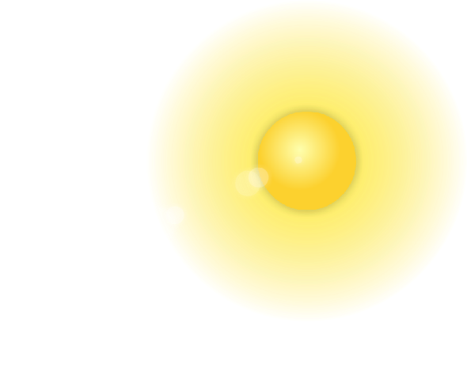
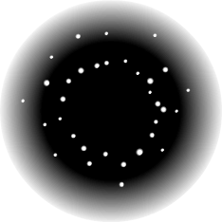



……………………………
……………………………
……………………………
……………………………
……………………………
……………………………
NEBULA
PROTOSTAR
MAIN SEQUENCE STAR
average star
massive star
remnant less than three Sun masses
remnant greater than three Sun masses
BLACK DWARF

