Speed and Acceleration Worksheet
This worksheet accompanies Speed.ppt and Acceleration.ppt

1. Speed is a scalar quantity, velocity is a vector quantity.
Define the words scalar and vector.

……………………………………………………………………………………………………………
……………………………………………………………………………………………………………

2. Give examples of one other scalar measurement and one other vector measurement.

……………………………………………………………………………………………………………
……………………………………………………………………………………………………………

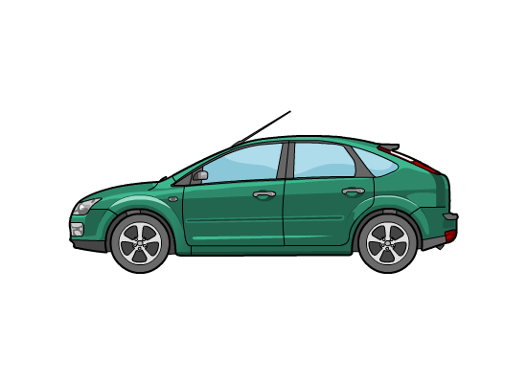
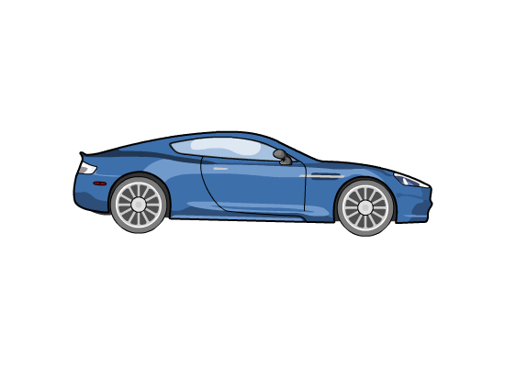
3. Calculate the relative velocity of the pairs of moving objects below

10 m/s
15 m/s

relative velocity = ..................................... relative velocity = .....................................
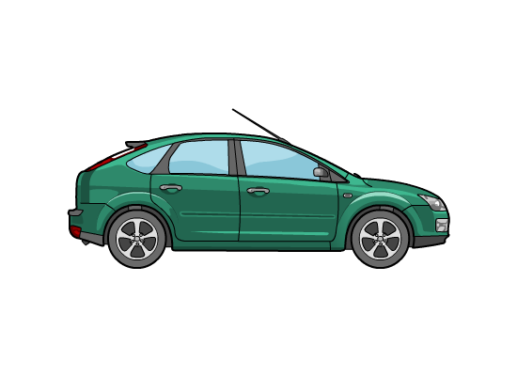

10 m/s
15 m/s

relative velocity = ..................................... relative velocity =.....................................

4. Calculate the speed (to 2 decimal places) of a boat that travels 100 m in 60 seconds.

……………………………………………………………………………………………………………
……………………………………………………………………………………………………………
……………………………………………………………………………………………………………

5. Calculate the distance travelled by a train travelling at 80 m/s for 60 minutes.

……………………………………………………………………………………………………………
……………………………………………………………………………………………………………
……………………………………………………………………………………………………………

6. Study the distance/time graph then use the information to answer the questions:
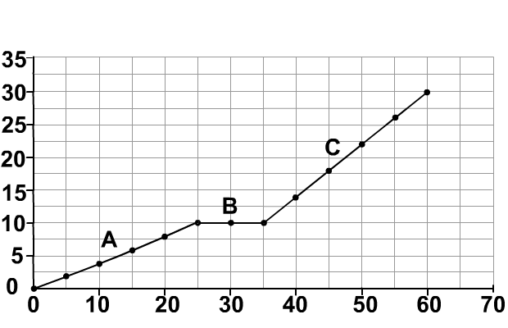

distance (m)

time (s)

a. What is the speed in section A?

…………………………………………………………………………………………………………
…………………………………………………………………………………………………………

b. What is the speed in section B?

…………………………………………………………………………………………………………
…………………………………………………………………………………………………………

c. What is the speed in section C?

…………………………………………………………………………………………………………
…………………………………………………………………………………………………………

d. What is the average speed for the whole journey?

…………………………………………………………………………………………………………
…………………………………………………………………………………………………………

7a. What is the acceleration of a sprinter if he increases
his speed from 0 m/s to 12 m/s in 0.5 seconds?

…………………………………………………………………………
…………………………………………………………………………
…………………………………………………………………………

b. If the sprinter has a mass of 60 kg, what is his accelerating force?

…………………………………………………………………………………………………………
…………………………………………………………………………………………………………
…………………………………………………………………………………………………………
8. A car engine provides a force of 3,500 N. If the car has a mass of 1,200 kg,
what is the maximum acceleration (to 2 decimal places) of the car?

……………………………………………………………………………………………………………
……………………………………………………………………………………………………………
……………………………………………………………………………………………………………

9. Study the velocity/time graph then use the information to answer the questions:

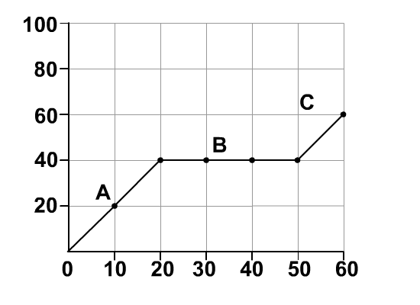

velocity (m/s)
time (s)

a. What is the acceleration in sections A, B and C?

A: ……………………………………………………………………………………………………
B: ……………………………………………………………………………………………………
C: ……………………………………………………………………………………………………

b. What is the total distance travelled for the whole journey?

…………………………………………………………………………………………………………
…………………………………………………………………………………………………………
…………………………………………………………………………………………………………

