Specific Heat Capacity Worksheet
This worksheet accompanies slide 12 of Specific Heat Capacity.ppt

A hot water bottle is filled with either water or vegetable oil. It is placed in the microwave until the temperature increases by 60ºC.
Using the data below, answer the questions. Recall the specific heat equation:
energy = mass × SHC × temperature change
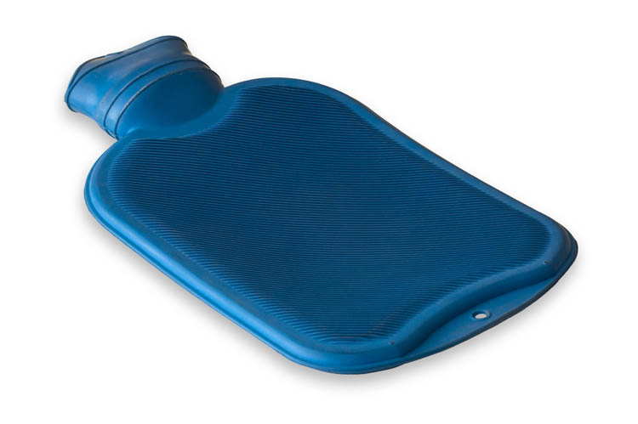
Mass of water in bottle …………..3 kg
Mass of oil in bottle ………………2 kg
Specific heat capacity of water …4200 J/kgºC
Specific heat capacity of oil …….1600 J/kgºC

© 2010 Photos.com

- Calculate the energy stored in the water-filled bottle.

Answer: ………………………

- Calculate the energy stored the oil-filled bottle.

Answer: ………………………

- Compare your answers to questions 1 and 2 and decide whether water or oil is best for use in the bottle. Give reasons for your choice.

Answer: ……………………………………………………………………………………
………………………………………………………………………………………………………………………………………………………………………………………………

