Resistance Worksheet
This worksheet accompanies Resistance.ppt

- Draw the circuit symbols for the components below:
Resistor | Variable resistor | Light dependent resistor | Thermistor

- How does resistance affect current?
Look at the circuit below, and write down what would happen to the bulb and the reading on the ammeter if the resistance of the variable resistor was decreased.
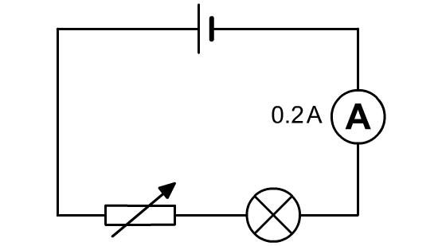
…………………………………………………………………..
…………………………………………………………………..
…………………………………………………………………..
…………………………………………………………………..
…………………………………………………………………..

- Calculate the resistance of a bulb if the current is 0.5 A and the voltage across the bulb is 6 V.
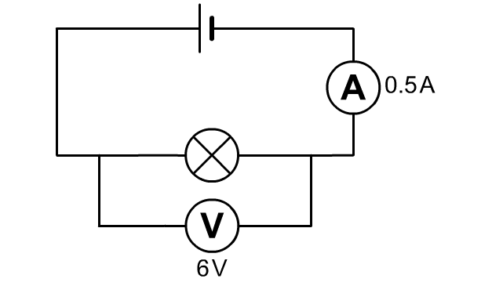
……………………………………………………………
……………………………………………………………
……………………………………………………………
……………………………………………………………
……………………………………………………………

- A student has recorded current and voltage results for two different wires, A and B, in the graph below. State which wire has the highest resistance and explain why.

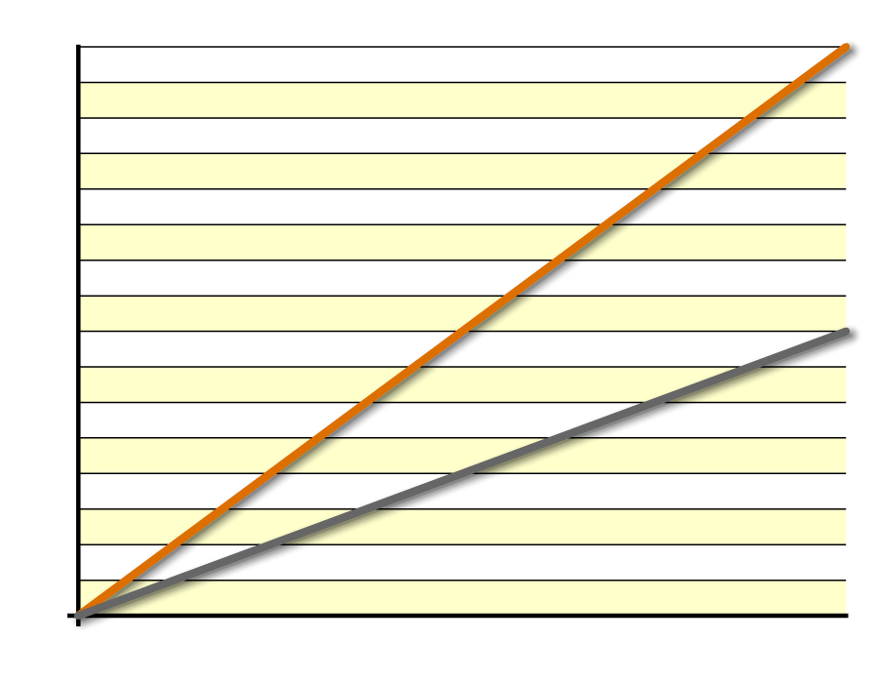
current (A)
B
A
voltage (V)

………………………………………………………………………………………………………………
………………………………………………………………………………………………………………
………………………………………………………………………………………………………………

- Fill in the blanks in the description of current in metallic conductors.

Current in a wire is the flow of charge carriers called ………….……………... . As the charge carriers move through a metallic conductor, they collide with ………….……………... in the metal. This increases the ………….……………... of the atoms, which increases the ………….……………... of the conductor. This increase makes it harder for the charge carriers to pass through, which in turn increases the ………….……………... of the material.

- The graph below shows the voltage and current data for a non-ohmic device.
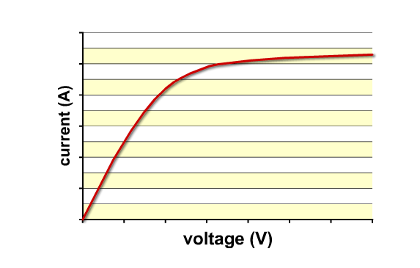
a. Why does it have this shape?
………………………………………………………………………………………………………
………………………………………………………………………………………………………
………………………………………………………………………………………………………
………………………………………………………………………………………………………
………………………………………………………………………………………………………
………………………………………………………………………………………………………
b. Give one example of a device with a graph this shape.

………………………………………………………………………………………………………

- Calculate the output voltage in the potential divider below.

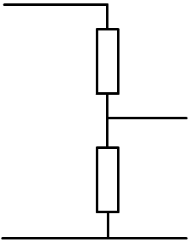
……………………………………………………
V_{IN}
12 V
0 V
R₁
3 Ω
R₂
15 Ω
0 V
V_{OUT}
……………………………………………………
……………………………………………………
……………………………………………………
……………………………………………………
……………………………………………………
……………………………………………………
……………………………………………………

- Sketch graphs on the axes below, showing how the resistance of light dependent resistors and thermistors vary with light and temperature.

resistance
light brightness
resistance
temperature
light dependent resistor
thermistor

- Calculate the total resistance of each of the following combinations of resistors:

