Reflection, Refraction and Diffraction Worksheet
This worksheet accompanies slide 5 of Reflection, Refraction and Diffraction.ppt

Complete the following diagrams to show reflection, refraction and diffraction.

1. Reflection: draw the reflected ray. Label the angle.
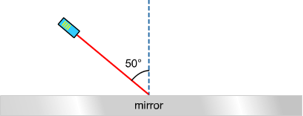

2. Refraction: draw the refracted ray.

Does the ray bend towards or away from the normal when it enters the glass?

……………………………

45°
air
glass

3. Diffraction: draw what happens to the water waves in each scenario.

a. wavelength same size as gap

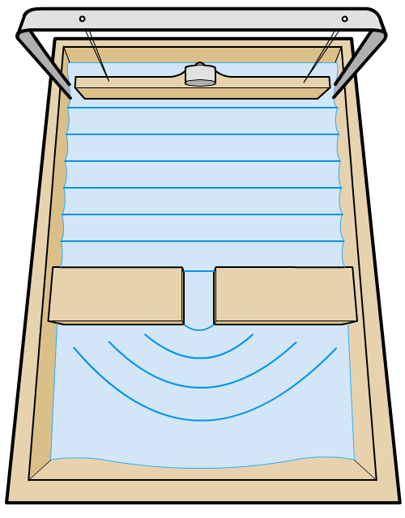

b. wavelength smaller than gap size

