Radioactive Substances Worksheet
This worksheet accompanies Radioactive Substances.ppt and Atoms and Isotopes.ppt

- In 1897, JJ Thomson discovered the existence of electrons in atoms. This led him to propose a model of an atom. What did he call this new model and why?
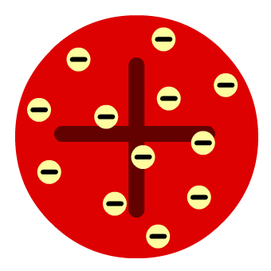
………………………………………………………………….……………………
…………………………………………………………………….………………
……………………………………………………………………….………………

- In the early 20th century, Ernest Rutherford (who had discovered alpha and beta radiation) asked his assistants, Geiger and Marsden, to investigate whether radiation emitted from a source would be reflected by gold foil. The results of the experiment found that while some alpha particles were deflected by the foil and a few bounced off, most of the alpha particles went straight through the foil, without any deflection.

a. How can these results be explained in terms of atoms?

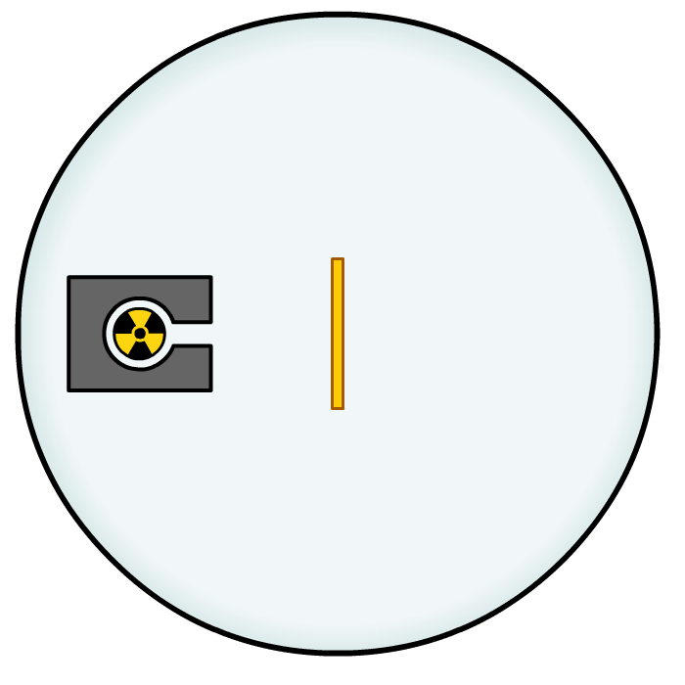
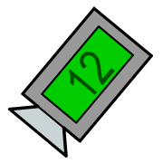
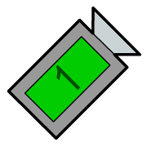
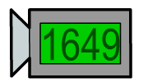
……………………………………………………………………………………………………………………………………………………………………………………………………………………………………………………………………………………………………………………………………………………………………………………………………………………………………………

b. How does this contradict Thomson’s model of the atom?

………………………………………………………………………………………………………………………………………………………………………………………………………………
- Ernest Rutherford later proposed the nuclear model of the atom to explain the findings of his experiments. This model still forms the basis of the modern model of the atom. Complete the following text using the words at the bottom of the page.

a. An atom is mainly empty space and most of its mass and its ………………… is in a tiny central nucleus. Electrons orbit this nucleus.
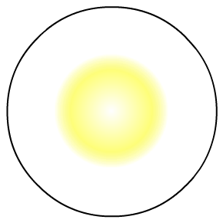



b. Further developments to this model showed that the atom is made up of three smaller particles: electrons, protons and ………………... .
c. The protons are found in the dense core at the centre of the atom
called the ………………... . The electrons are scattered around the
edge of the atom and orbit the nucleus in layers called shells.
d. Two important properties of the particles in an atom are ………………… and electrical charge. The atoms of an element contain ………………… numbers of protons and electrons which means they have no overall charge. This means that if a proton has an overall charge of +1, the electron charge must be …………….......

nucleus | positive charge | –1 | +1 | equal
higher | neutrons | isotopes | negative charge | mass

4. Atoms of the same element always have the same number of protons, but the number of neutrons may be different. What are atoms that differ in this way known as?

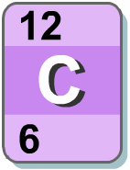
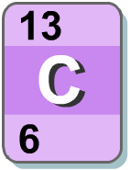
…………………………………………………

5. What is an ion?

………………………………………………………………………………………………….….……………………………………………………………………………………………….……………….

6. What is a radioactive substance?

………………………………………………………………………………………………….….……………………………………………………………………………………………….……………….…………………………………………………………………………………………………………….….………………………………………………………………………………………………………

7. What is background radiation and where does it come from?

………………………………………………………………………………………………….….……………………………………………………………………………………………….……………….…………………………………………………………………………………………………………….….………………………………………………………………………………………………………

8. How does a Geiger-Müller counter work?

………………………………………………………………………………………………….….……………………………………………………………………………………………….……………….…………………………………………………………………………………………………………….….………………………………………………………………………………………………………

