Power Stations Worksheet
This worksheet accompanies slide 4 of Power Stations.ppt

1. Below is a diagram of a coal-fired power station. Name the parts labelled A to D.

D: ……………………………
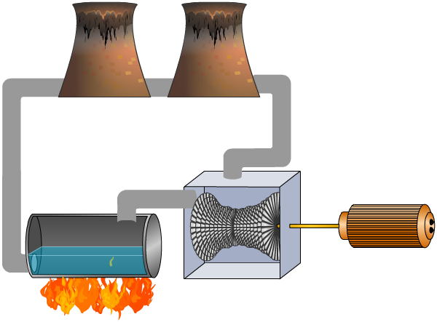

A: ……………………………
B: ……………………………
C: ……………………………
2. Write down what happens in each of the five parts of the power station.

In A: ……………………………………………………………………………………………………………
……………………………………………………………………………………………………………
……………………………………………………………………………………………………………

In B: ……………………………………………………………………………………………………………
……………………………………………………………………………………………………………
……………………………………………………………………………………………………………

In C: ……………………………………………………………………………………………………………
……………………………………………………………………………………………………………
……………………………………………………………………………………………………………

In D: ……………………………………………………………………………………………………………
……………………………………………………………………………………………………………
……………………………………………………………………………………………………………

