Particles and Energy Transfer Worksheet
This worksheet accompanies slide 11 of Particles and Energy Transfer.ppt

1. Investigating conduction in different metals
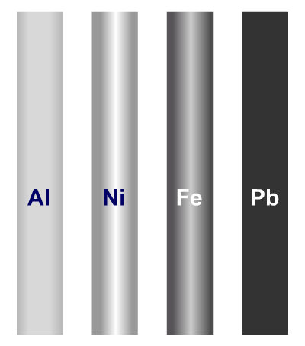
Before watching the virtual experiment on slide 11, design an experiment using the listed apparatus to test how four different metal rods conduct heat. Draw a diagram of how the experiment should be set up below.

Some materials you may wish to consider using include:
Bunsen burner, tape, pins, petroleum jelly,
thermometer, stopwatch, hotplate.

Assume that you have access to standard lab equipment, such as stands, beakers and clips.
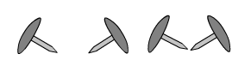
2. What are the independent, dependent and control variables in your experiment?
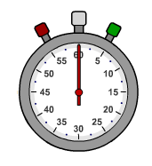
independent: …………………………………………………………………………………………
dependent: ……………………………………………………………………………………………
control: ……………………………………………………………………………………………

3. How would you make your results valid and reliable?

valid: ……………………………………………………………………………………………………
……………………………………………………………………………………………………
reliable: …………………………………………………………………………………………………
……………………………………………………………………………………………………

4. Write a method explaining how you would carry out your experiment.
Your target audience is an average Year 9 student, so you will need to use
appropriate language.

………………………………………………………………………………………………………………
………………………………………………………………………………………………………………
………………………………………………………………………………………………………………
………………………………………………………………………………………………………………
………………………………………………………………………………………………………………
………………………………………………………………………………………………………………
………………………………………………………………………………………………………………
………………………………………………………………………………………………………………
………………………………………………………………………………………………………………
………………………………………………………………………………………………………………
………………………………………………………………………………………………………………
5. Conclusion

a. After watching the virtual experiment on slide 11, list the metals in order of the time it
takes for heat to conduct along the rod.

slowest: .………….…………………………………………
.………….…………………………………………
.………….…………………………………………
fastest: .………….…………………………………………

b. List the metals in order of their ability to conduct heat. How will you determine this?

best: .………….…………………………………………
.………….…………………………………………
.………….…………………………………………
worst: .………….…………………………………………

