Particle Physics Worksheet
This worksheet accompanies Particle Physics.ppt

1. Complete the table with the missing values:

particle | relative mass | relative charge
neutron | 1
proton |  | +1
electron

positron | 0.0005

2. Using the information about quarks from the table, determine the quark composition of a proton and a neutron.

quark | symbol | relative charge
up  | u | +2/3
down  | d | –1/3

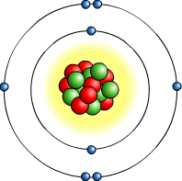

proton: ……………………………

neutron: ……………………………

3. Below is carbon-12 in isotope form. Write two additional isotopes of carbon in isotope form:

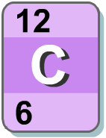

……… ………
C C
……… ………

4. Complete the following decay equations by…

a. filling in the missing numbers for alpha decay:

238
92
U
Th + α
………
………
………
………

b. filling in the missing symbol for beta decay:

14
6
C
N + β
………
14
7

5. Annihilation occurs when a particle meets its antiparticle.

a. Draw a diagram representing annihilation:

b. State two quantities that must be conserved during annihilation:

i. ………………………………………… ii. …………………………………………

- Electron tubes are used to accelerate electrons that eventually strike a target to make radiation such as X-rays.

a. Add arrows to the diagram below to show the direction of the electrons and current in the electron tube:

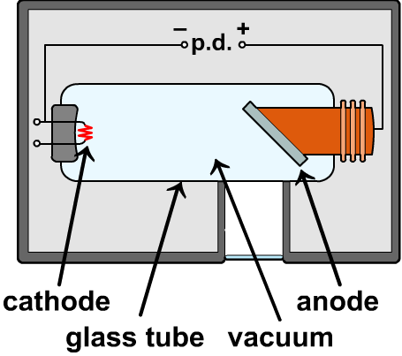

- Using the data given in the table, calculate…

charge on electron | 1.6 × 10^{–19} C
accelerating voltage (p.d.) | 2,000 V
particles per second emitted | 4.8 × 10¹⁸ particles

i. the current in the electron tube: ………………………………………

ii. the kinetic energy of each electron: ………………………………………

- Describe two uses of particle accelerators, such as cyclotrons.

…………………………………………………………………………………………………………
…………………………………………………………………………………………………………
…………………………………………………………………………………………………………
…………………………………………………………………………………………………………
…………………………………………………………………………………………………………
…………………………………………………………………………………………………………
…………………………………………………………………………………………………………
…………………………………………………………………………………………………………

