Observing Space Worksheet
This worksheet accompanies Motion in the Solar System.ppt,
Observing the Stars.ppt and Stars.ppt

1. Fill in the gaps in the sentences below.

A solar day lasts for …………………….. It is measured relative to the position of the sun.
A sidereal day lasts …………………….. and it is measured relative to distant objects such
as stars. The Earth rotates 360° in a …………………….. day.

2. a. Add rays to the diagram below to show how a solar eclipse is formed. Identify where the eclipse is observed by marking an X on the surface of the Earth.
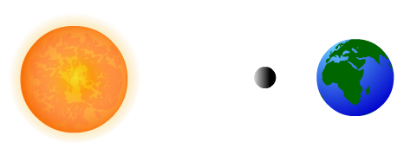
b. Explain why solar and lunar eclipses are rare.

……………………………………………………………………..…………………………………
…………………………………..……………………………………………………………………
……………………………………………………………………..…………………………………
…………………………………..……………………………………………………………………

3. Explain why planets sometimes seem to move in retrograde motion with respect to the fixed stars. You may use a diagram to help you.

…………………………………………………………………………..…………………………………

………………………………………..……………………………………………………………………

…………………………………………………………………………..…………………………………
………………………………………..……………………………………………………………………
Diagram:

4. Estimate the position on the celestial sphere of the star indicated by a yellow dot on the diagram below, using declination and right ascension.
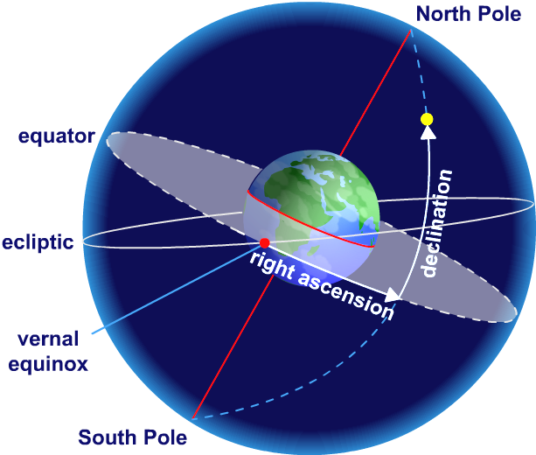
………………………………………..……
………………………………………..……
………………………………………..……
………………………………………..……
………………………………………..……
………………………………………..……
………………………………………..……
………………………………………..……
………………………………………..……
5. Describe what is unusual about Cepheid variable stars and how this allows the distance to them to be estimated.

………………………………………..……………………………………………………………………
………………………………………..……………………………………………………………………
………………………………………..……………………………………………………………………
………………………………………..……………………………………………………………………
………………………………………..……………………………………………………………………
………………………………………..……………………………………………………………………
6. Using the equation below, calculate the speed of recession in km/s of a galaxy estimated to be 6 Mpc from Earth.
Take the Hubble constant to be 70 km/s per Mpc.

speed of recession = Hubble constant × distance

………………………………………..……………………………………………………………………
………………………………………..……………………………………………………………………
………………………………………..……………………………………………………………………
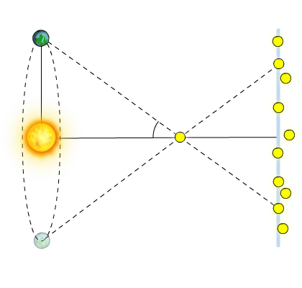
7. a. Explain what the parallax angle of a star is. You may label the diagram to aid your explanation.

…………………………………..…………………………
…………………………………..…………………………
…………………………………..…………………………
……………………………………………………………..
……………………………………………………………..
b. A star has a parallax angle of 6 arcseconds. Calculate the distance to the star in parsecs.

…………………………………..……………………………………………………………………
…………………………………..……………………………………………………………………
…………………………………..……………………………………………………………………
8. a. List two features you would look for in a site for a new astronomical observatory.

i. ………………………………………..……………………………………………………………
ii. ………………………………………..……………………………………………………………
b. Give two reasons to use a telescope outside the Earth’s atmosphere instead of an observatory located on the Earth’s surface.

i. ………………………………………..……………………………………………………………
ii. ………………………………………..……………………………………………………………

9. Describe how line spectra can be used to identify the elements present in stars.

………………………………………..……………………………………………………………………
………………………………………..……………………………………………………………………
………………………………………..……………………………………………………………………
………………………………………..……………………………………………………………………
………………………………………..……………………………………………………………………
………………………………………..……………………………………………………………………

10. a. Fill in the gaps in the sentences below.


In a ……………………………star, …………………is formed when hydrogen fuses in the core. When the core hydrogen runs out, the star swells and becomes a red giant or supergiant. Heavier nuclei are formed. The more massive the star, the …………………the core and the …………………the nuclei it can create by fusion. The most massive stars can produce …………………nuclei. When a supergiant explodes in a …………………, these heavy nuclei fuse to create nuclei with masses ……………… than ………………….

b. Explain why most fusion happens in the core of a star.

…………………………………..………………………………………………
…………………………………..……………………………………………………………………
…………………………………..……………………………………………………………………
…………………………………..……………………………………………………………………

