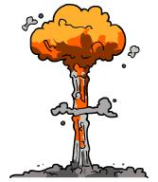
Nuclear Power Worksheet
This worksheet accompanies Nuclear Fuels and Fission.ppt and Nuclear Fusion.ppt

1. Fill in the gaps using the words below.

………………… predicted that a ………………… amount of matter could release a huge amount of energy in a nuclear reaction, and he was right! Massive amounts of energy can be produced by the ………………… in atoms. This energy can be released in two ways:
- by splitting atomic nuclei in a process called nuclear …………………
- by joining nuclei together in a process called nuclear ………………….

fusion | huge | Einstein | Newton
fission | small | nuclei | electrons

2. Why is the amount of energy released during nuclear fission and fusion much greater than the amount of energy released during chemical reactions?

……………………………………………………………………………………………………………………………………………………………………………………………………………………………………………………………………………………………………………………………………………………………………………………………………………………………………………………
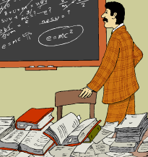
3. The equation E = mc² is used to calculate the energy
released during nuclear reactions. If ‘E’= energy
produced, and ‘m’ = mass, what does ‘c’ stand for?

………………………………………………………………
4. Nuclear fission is used to generate heat in a reactor in a nuclear power station. Explain what happens to enable the nuclear fuel to release energy. Include the
following terms in your answer: nucleus, neutrons, splitting, energy, fuel rods,
absorb, unstable, and daughter nuclei.

………………………………………………………………………………………………………………………………………………………………………………………………………………………………………………………………………………………………………………………………………………………………………………………………………………………………………………………………………………………………………………………………………………………………………………………………………………………………………………………………………………

5. How is electricity generated at a nuclear power station?

……………………………………………………………………………………………………………….……………………………………………………………………………………………………………….……………………………………………………………………………………………………………….……………………………………………………………………………………………………………….……………………………………………………………………………………………………………….…………………………………………………………………………………………………………….………………………………………………………………………………
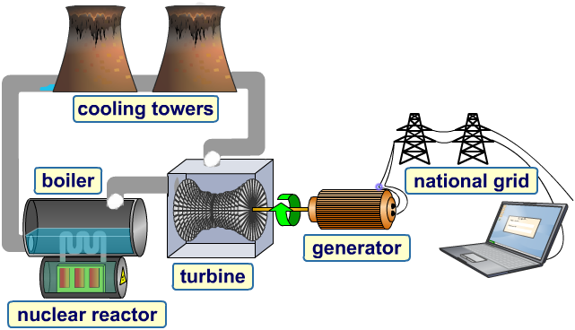
……………………………………
……………………………………
……………………………………
……………………………………
……………………………………
6. Nuclear fission results in a chain reaction because each time a nucleus splits it releases more neutrons, which can cause more fission reactions to occur. This means that nuclear fission releases a lot of energy and heat very rapidly and so it can be very dangerous if it is not properly controlled.

a. Give one example of a nuclear incident in which chain reactions got out of control.

…………………………………………………………………………………………………………
…………………………………………………………………………………………………………
…………………………………………………………………………………………………………

b. Give one example of how humans can use uncontrolled chain reactions which release huge amounts of energy to their advantage.

…………………………………………………………………………………………………………
…………………………………………………………………………………………………………
…………………………………………………………………………………………………………

c. Give one advantage and one disadvantage of nuclear fission.

Advantage: ………………………………………………………………………………………....
………………………………………………………………………………………...…………........
………………………………………………………………………………………...…………........

Disadvantage: ……………………………………………………………………………………....
………………………………………………………………………………………...…………........
………………………………………………………………………………………...…………........

7. Fill in the gaps using the words below.

Nuclear fusion is the process of joining two small nuclei to form a larger one. The process involves bringing two …………………… atoms close enough to make them fuse to form ……………………. This process happens in stars and at very high …………………… and pressures. These conditions are necessary to overcome the electrostatic …………………… forces between all the …………………… and neutrons in the nuclei and force them together.

hydrogen | attractive | neutral | electrons
repulsive | helium | temperatures | protons

8a. Give one reason why nuclear fusion is not yet an economic or practical form of generating power.

……………………………………………………………………………………………………………………………………………………………………………………………………………………
…………………………………………………………………………………………………………
…………………………………………………………………………………………………………

b. Give one advantage of using fusion energy to generate power.







