Motors, Generators and Transformers Worksheet
This worksheet accompanies Motors.ppt, Generators.ppt, and Transformers.ppt

1. The diagrams below show current-carrying wire in different shapes. Draw the shape of the magnetic field around the wires.

straight wire solenoid

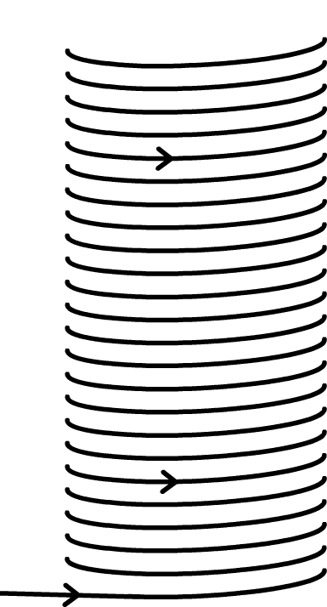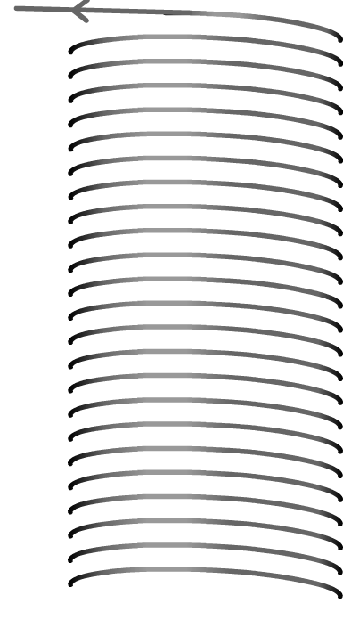

2. When current flows through a wire held in a magnetic field, a force is created that moves the wire.

a. What happens if the current is parallel to the magnetic field?

…………………………………………………………………………..…………………………………
…………………………………………………………………………..…………………………………

b. List two factors that affect the size of the force produced.

i. ……………………………………………………………………………………………
ii. ……………………………………………………………………………………………

c. The straight wire in the diagram below is being held loosely. The direction of the current and the magnetic field are shown. Draw an arrow showing the direction of the force acting on the wire.

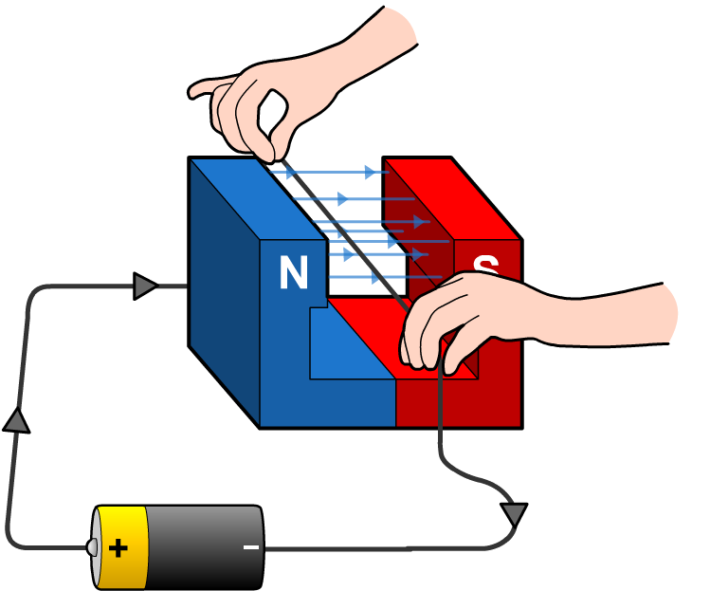

3. Forces created in this way are often used to turn motors.

a. Describe how a turning effect is produced on a current-carrying coil of wire in a magnetic field.

…………………………………………………………………………..…………………………………
………………………………………..……………………………………………………………………
……..…………………………………………………………………………..………………………….

b. Describe how the direction of the force is maintained in a simple DC electric motor.

…………………………………………………………………………..…………………………………
………………………………………..……………………………………………………………………
……..…………………………………………………………………………..………………………….
4. Explain with the aid of a diagram how a voltage can be induced in a straight wire using a magnet. Label your diagram with the direction of the magnetic field and the direction of the current.

Diagram

Explanation:

…………………………………………………………………………..…………………………………
………………………………………..……………………………………………………………………
……..…………………………………………………………………………..………………………….

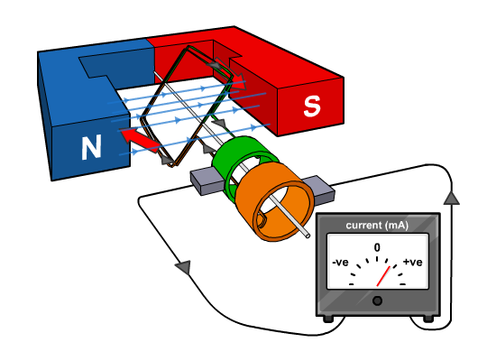
5. The diagram shows a simple AC generator. Fill in the table below with the names of the numbered parts and their function.
1

2

3

 | name | function
1
2
3
6. The AC generator pictured in the previous question is a simple way to generate electricity.

a. Describe an alternative way a magnet and coil can be arranged to generate electricity in power stations.

…………………………………………………………………………..…………………………………
………………………………………..……………………………………………………………………
……..…………………………………………………………………………..………………………….

b. Describe two ways to increase the size of the voltage generated and state whether each one has an effect on the frequency.

i. ……………………………………………………………………………………………..
……..…………………………………………………………………………..………………...
ii. ……………………………………………………………………………………………..
……..…………………………………………………………………………..………………...

7. Fill in the gaps in the sentences about transformers below.

……….………..……….. current in the primary side of the transformer makes the magnetic field around the transformer alternate. This ……….………..……….. current in the secondary side coil. A step-up transformer is used to decrease ……….………..……….. and increase ……….………..……….., and a step-down transformer increases ……….………..……….. and decreases ……….………..……….. The total ……….………..……….. remains constant.

8. The diagram shows a simple transformer.

a. State with a reason whether the transformer shown is a step-up or step-down transformer.
secondary side
primary side
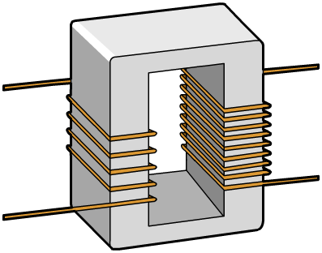
……..…………………………………………………………
………………..………………………….……..……………
……………………………………………………………..…
……………………….……..…………………………………
………………………………………..………………………
………………………………………..………………………

b. The transformer shown has four turns in the primary coil and nine turns in the secondary coil. If the voltage across the primary coil is 8 V, what is the voltage across the secondary coil?

……..…………………………………………………………………………..………………………….
……..…………………………………………………………………………..………………………….
……..…………………………………………………………………………..………………………….

c. If the current in the primary coil is 10 A, what is the current in the secondary coil? Assume the transformer is 100% efficient.

……..…………………………………………………………………………..………………………….
……..…………………………………………………………………………..………………………….
……..…………………………………………………………………………..………………………….

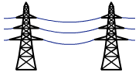
9. Give an equation relating power loss and current and use it to explain why electricity is transmitted at high voltages.

Equation:……..……………………………………………………………
……..………………………………………………………………………
……..…………………………………………………………………………..………………………….
……..…………………………………………………………………………..………………………….
……..…………………………………………………………………………..………………………….
……..…………………………………………………………………………..………………………….

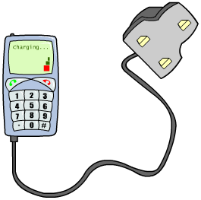
10. List two advantages of switch mode transformers over traditional transformers.

a. …………………………………………………………………
……..………………………………………………………………..
b. …………………………………………………………………
…...……..……………………………………………………………

11. Isolating transformers provide the same secondary voltage as the primary voltage.

a. What is the relationship between the number of coils on the primary and secondary circuits in an isolating transformer?

……..…………………………………………………………………………..………………………….
b. Explain why isolating transformers are used and give one example of where they are used.

……..…………………………………………………………………………..………………………….
……..…………………………………………………………………………..………………………….
……..…………………………………………………………………………..………………………….
……..…………………………………………………………………………..………………………….

