Medical Physics Worksheet
This worksheet accompanies Medical Physics.ppt

1. The picture shows an X-ray photograph of a foot.

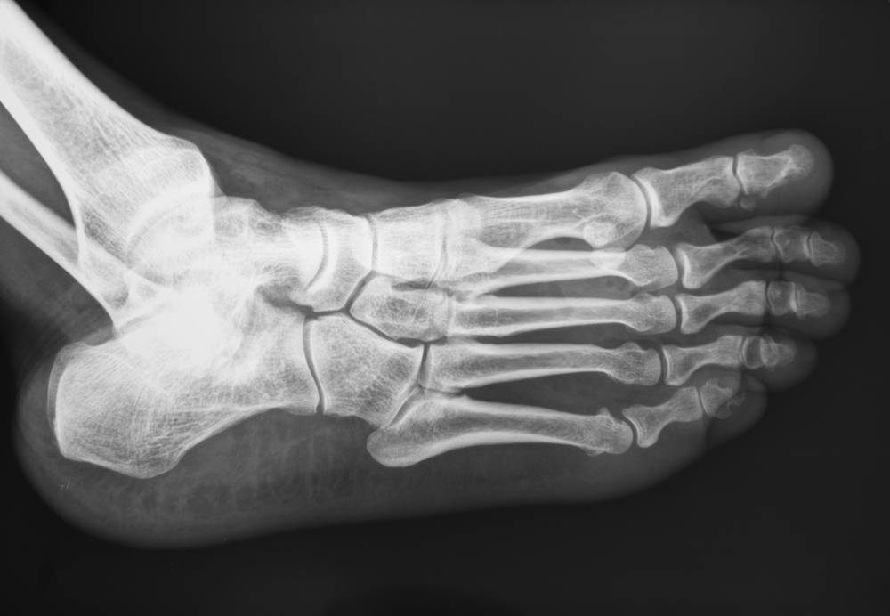
Photo credit: © zhu difeng, Shutterstock.com 2012

a. Describe how X-rays interact with different materials to produce the image.

………………………………………………………………………………………………………………
………………………………………………………………………………………………………………
………………………………………………………………………………………………………………
………………………………………………………………………………………………………………

b. Write down one reason why a CT scan might be used instead of an X-ray.

………………………………………………………………………………………………………………
………………………………………………………………………………………………………………
………………………………………………………………………………………………………………
………………………………………………………………………………………………………………

2. Some types of ionizing radiation can be used to treat cancer.

- Fill in the gaps in the sentences below.

In external beam radiotherapy, a beam of high-energy ionizing radiation is targeted at ……………………… cells from a radiation source outside the body. To minimise the harm to ……………………… cells, the radiation beam is …………………………… so that the tumour is targeted from ……………………………………. This means that the tumour receives ……………… radiation than the surrounding cells.

b. Some types of radiotherapy involve putting a radioactive source inside a patient. What two types of radiation can be used for internal radiotherapy?

i. ……………………………………………………………………………………………
ii. ……………………………………………………………………………………………

c. Describe one advantage of putting a radioactive source inside the body instead of using external beam radiotherapy.

………………………………………………………………………………………………………………
………………………………………………………………………………………………………………
………………………………………………………………………………………………………………
………………………………………………………………………………………………………………

3. Administering X-rays and external beam radiotherapy can be dangerous. Write down three safety precautions that could be used to protect a radiographer.

i. …………………………………………………………………………………………………...
ii. …………………………………………………………………………………………………...
iii. …………………………………………………………………………………………………...
4. PET scanning is a type of imaging which uses radioactive isotopes.

a. What type of particle is emitted by the isotopes?

………………………………………………………………………………………………………………
b. The PET scanner detects gamma rays. How is this gamma radiation produced?

………………………………………………………………………………………………………………
………………………………………………………………………………………………………………
………………………………………………………………………………………………………………
………………………………………………………………………………………………………………
c. Why is an isotope with a short half-life used?

………………………………………………………………………………………………………………
………………………………………………………………………………………………………………
………………………………………………………………………………………………………………

………………………………………………………………………………………………………………
5. An ultrasound pulse is sent out by a ship. An echo is detected 0.03 seconds later. The speed of sound in water is 1500 m/s. Calculate the distance from the ship to the sea bed.

The distance from the ship to the sea bed is….…………………..m.
6. Give two examples of how ultrasound can be used in medicine.

i. ……………………………………………………………………………………………
ii. ……………………………………………………………………………………………
7. The graph shows a section of an electrocardiogram (ECG) of a normal healthy heart.
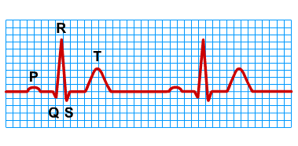
Fill in the gaps in the sentences below.

An ECG is used to monitor the ………………………………………… of the heart. This graph shows the heart beating ……… times. The P wave shows the …………………… contracting. The section labelled QRS shows a powerful contraction of the ……………………, pumping the blood around the body.

