Mechanics Worksheet
This worksheet accompanies Mechanics.ppt

1. The diagram shows a thin symmetrical card. Draw a line on the diagram which the centre of mass must lie along.

2. The diagram shows a thin irregularly shaped card. Describe an experiment which could be used to find the centre of mass of the card.

…………………………………………………………………………..
…………………………………………………………………………..
…………………………………………………………………………..
…………………………………………………………………………..
…………………………………………………………………………..

3 A pendulum

a. The pendulum has a time period of 4 seconds. What is its frequency?

The frequency of the pendulum is ……..……………………………………………………………Hz.
b. The pendulum is released at an angle of 30° to the vertical.
Where is it 2 seconds after release?

The pendulum is ………………………………………………………………..………………………….

4. Write down the only factor which has an affect on the time period of a pendulum.
………………………………………..……………………………………………………………………

5. Calculate the moment applied by the force below.
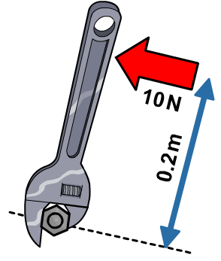

The moment applied by this force is…………………………………..Nm.

6. Use the principle of moments to explain why the scales are balanced.
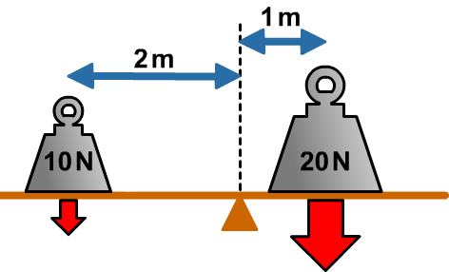
…………………………………………………………
…………………..………………………………………
………………………………………..…………………
…………………………………………………………
…………………………………………………………

7. A rock with a mass of 100 N is balanced on a plank, 0.1 m from the pivot.
A force is applied to the plank at a distance of 1.5 m on the other side of the pivot. Calculate the force.
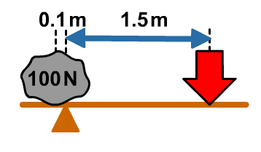

The force is …….……………………………………………...N.

8. Write down which of these objects is most stable and explain your choice in terms of each object’s tendency to topple.











