Lenses Worksheet
This worksheet accompanies The Eye and Vision.ppt, Lenses.ppt, and Telescopes.ppt

1. Label the picture of the eye below.
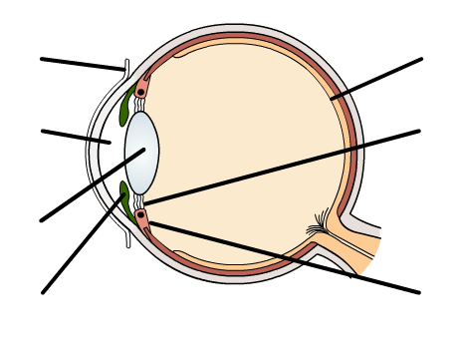
……………………………
……………………………

……………………………
…………………………………………………………..

…………………………

…………………………………………………………..

……………………………

2. Add these labels to the diagram of a convex lens below:

principle axis focal length focal point optical centre of lens



3. Draw a diagram below to show how a concave lens refracts and focuses light.
Mark the focal point on the diagram.

4. Fill in the table below giving two possible causes of long and short sight and the type of lens that would be used to correct each type of vision.

type of vision | possible causes | lens
short sight | 1.……………………...........................................  ……………………………………………………  2 .……………………..........................................  …………………………………………………… | ……………………….
long sight | 1.……………………...........................................  ……………………………………………………  2……………………...........................................  …………………………………………………… | ……………………….
5. Write down the similarities and differences between real and virtual images.

Real images
………………………………………………………………………………………………………………
………………………………………………………………………………………………………………
………………………………………………………………………………………………………………
Virtual images
………………………………………………………………………………………………………………
………………………………………………………………………………………………………………
………………………………………………………………………………………………………………

6. a. The object shown is between one and two focal lengths from the convex lens. Complete the ray diagram for light passing through the lens from the object and draw the image formed.

b. Circle the words that apply to the image:

real | virtual | upright | inverted | magnified | diminished
7. Write down how a convex lens can be used as a magnifying glass.

………………………………………………………………………………………………………………
………………………………………………………………………………………………………………
………………………………………………………………………………………………………………
………………………………………………………………………………………………………………
………………………………………………………………………………………………………………

8. A lens has a focal length of 10 cm. Calculate its power. Remember to give units.

9. An object with a height of 20 cm is placed 40 cm from a convex lens of focal length 10 cm.

a. Use the lens equation to find out the position of the image.

b. Using the scale 1 box = 5 cm, draw a scale diagram on the grid below to find the size of the image.

c. Calculate the magnification.

10. A telescope is constructed from two lenses. The focal length of the eyepiece lens is 5 cm, and the focal length of the objective lens is 70 cm.

a. Calculate the angular magnification of the telescope.

b. Explain why most astronomers use reflecting telescopes instead of refracting telescopes.

………………………………………………………………………………………………………………
………………………………………………………………………………………………………………
………………………………………………………………………………………………………………
………………………………………………………………………………………………………………
………………………………………………………………………………………………………………
………………………………………………………………………………………………………………
………………………………………………………………………………………………………………
………………………………………………………………………………………………………………
………………………………………………………………………………………………………………

