Generators Worksheet
This worksheet accompanies slide 12 of Generators.ppt

1. Label the following parts of the diagram below:
slip rings
magnet
coil
carbon brushes
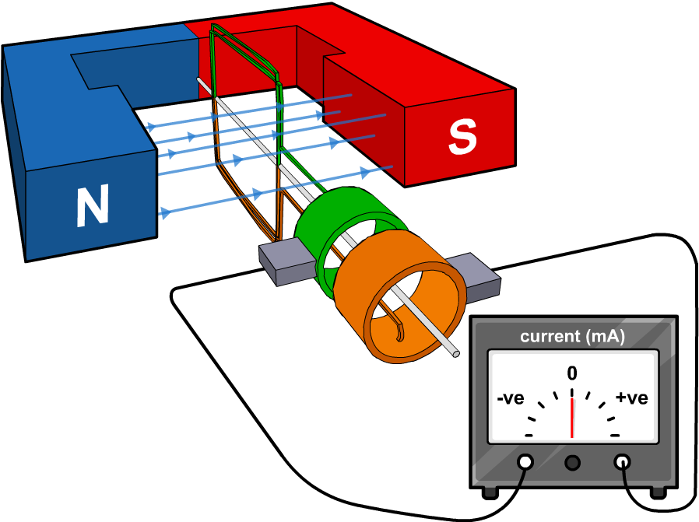

2. Describe what happens to the ammeter reading when the coil rotates.

……………………………………………………………………………………………………………
……………………………………………………………………………………………………………

3. What would happen to the ammeter reading if a stronger magnet was used?

……………………………………………………………………………………………………………
……………………………………………………………………………………………………………

4. What would happen if the coil had lots of turns instead of just one?

……………………………………………………………………………………………………………
……………………………………………………………………………………………………………

5. What would happen if the coil was rotated faster?

……………………………………………………………………………………………………………
……………………………………………………………………………………………………………

