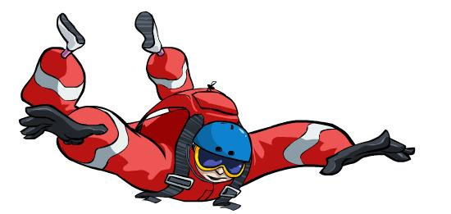
Forces Worksheet
This worksheet accompanies Forces.ppt

1. Fill in the gaps in the sentences using the words below.

a. When two objects interact, the forces they exert on each other are equal in size and …………………… in direction.
b. The pair of forces that acts between two objects is called an ……………………… pair or an ……………………… pair.
c. The forces that are exerted when two forces interact are called ………………………
d. A person’s weight pushes down on the ground because of the Earth’s ……………………… The ground exerts an ……………………… and opposite force pushing upwards on the person. This is called the ………………………

interaction | opposite | reaction forces | action–reaction
gravity | equal | reaction of the surface

2. Draw arrows on the images to show the action–reaction forces that occur when a rocket takes off into the sky and when an object falls to the ground from a shelf.
Explain what happens and why.
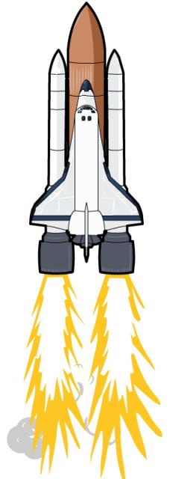

Rocket taking off:
……………………………………………………………
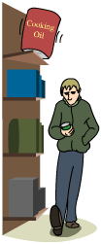
……………………………………………………………

Object falling to the ground:
……………………………………………………………
……………………………………………………………
3. If the downward force exerted by a stationary object increases, the reaction of the surface will also increase to match it (up to a certain limit). Explain what would happen if the downward force (i.e. the weight) of a rowing boat in a river exceeded the reaction of the surface of the water beneath it.

……………………………………………………………………………………………………………………………………………………………………………………………………………………………………………………………………………………………………………………………………………………………………………………………………………………………………………………

4. Explain what friction is and what would happen if it did not exist.

……………………………………………………………………………………………………………………………………………………………………………………………………………………………………………………………………………………………………………………………………………………………………………………………………………………………………………………

5. Give one advantage and one disadvantage of friction acting on a moving car.

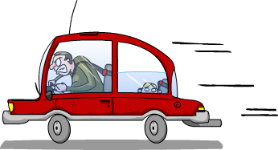
……………………………………………………………………………………………………………………………………………………………………………………………………………………………………………………………………………………………………………………………………………………………………………………………………………………………………………………

6a. Fill in the missing words to show the forces acting on this boat. 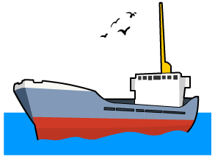
………………..
upthrust
friction
thrust
…………………

b. Describe what would happen if the driving force (the thrust) remained the same as the counter force (friction) acting on the moving boat.

………………………………………………………………………………………………………………………………………………………………………………………………………………………………………………………………………………………

c. Describe what would happen if the driving force became greater than the counter-force.

……………………………………………………………………………………………………………………………………………………………………………………………………………………………………………………………………………………...
7. Calculate the resultant forces and the direction of movement for the aeroplane.
Show your working.
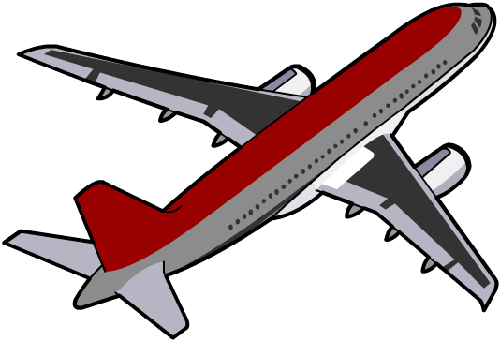
6,000 N
6,000 N

2,500 N

2,500 N
2,000 N

……………………………………………………………………………………………………………
……………………………………………………………………………………………………………
……………………………………………………………………………………………………………
……………………………………………………………………………………………………………
……………………………………………………………………………………………………………
……………………………………………………………………………………………………………

8. Explain what would happen if the resultant force acting on a moving car increased from 1,000 N to 1,300 N.

…………………………………………………………………………………………………………………………………………………………………………………………………………………………
……………………………………………………………………………………………………………
……………………………………………………………………………………………………………
……………………………………………………………………………………………………………

