Electronics Worksheet
This worksheet accompanies Logic Gates.ppt and Diodes Capacitors and Transistors.ppt

1. A student investigated the current–voltage characteristics of a diode and wrote their results in the table.

a. Plot the results on the graph paper below:

Voltage (V) | Current (A)
1.0 | 1.0
0.8 | 0.3
0.6 | 0.1
0.4 | 0.0
0.2 | 0.0
–0.2 | 0.0
–0.4 | 0.0
–0.6 | 0.0
–0.8 | 0.0
–1.0 | 0.0

b. Use your graph to find the resistance at 0.2 V, 0.6 V and 1.0 V.

……………………………………………………………………..…………………………………
……………………………………………………………………..…………………………………
……………………………………………………………………..…………………………………
……………………………………………………………………..…………………………………
……………………………………………………………………..…………………………………
……………………………………………………………………..…………………………………
……………………………………………………………………..…………………………………
……………………………………………………………………..…………………………………

2. A fully-charged capacitor is connected in a circuit to discharge and the current is monitored over time.

a. Sketch the circuit in the space below using some or all of these symbols:

b. Sketch the shape of the current–time graph for the discharging capacitor on the graph paper.

3. Fill in the blanks in the sentences below:

Electrical energy is transported around the country using alternating current (AC) but electronic devices need ……………………………… (DC) supplies. To convert AC into DC, a single diode can be used for………………….. rectification. This means the signal always flows in the same direction. Four diodes can be combined in a bridge circuit which produces ………………….. rectification. The signal produced is ………………….. DC, as its voltage still varies.

4. On the oscilloscope screens below, draw the stages seen when changing AC to DC.

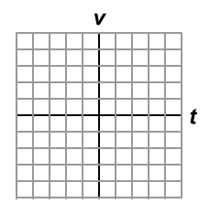  AC signal | half-wave rectification
full-wave rectification | smoothed signal

5. Complete the truth tables for the logic gates below:
in A | in B | out
0 | 0
0 | 1
1 | 0
1 | 1
AND gate OR gate NAND gate

in A | in B | out
0 | 0
0 | 1
1 | 0
1 | 1
in A | in B | out
0 | 0
0 | 1
1 | 0
1 | 1
6. Sketch a circuit diagram in the space below to show how two transistors are used to construct an AND gate.

7. The diagram below shows a simple potential divider.

a. Add these labels to the diagram: V_{out} V_{in} O V
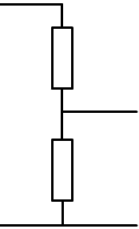

b. Describe how you would alter the circuit so that the output voltage would increase as the temperature increases.

……………………………………………………………………..…………………………………
……………………………………………………………………..…………………………………
……………………………………………………………………..…………………………………
……………………………………………………………………..…………………………………
……………………………………………………………………..…………………………………
……………………………………………………………………..…………………………………
……………………………………………………………………..…………………………………

8. Describe how a relay works and give an example of where it might be used.

…………………………………………………………………………..…………………………………
…………………………………………………………………………..…………………………………
…………………………………………………………………………..…………………………………
…………………………………………………………………………..…………………………………
…………………………………………………………………………..…………………………………
…………………………………………………………………………..…………………………………
…………………………………………………………………………..…………………………………
…………………………………………………………………………..…………………………………

