Electromagnetic Spectrum Worksheet
This worksheet accompanies slide 22 of Electromagnetic Spectrum.ppt

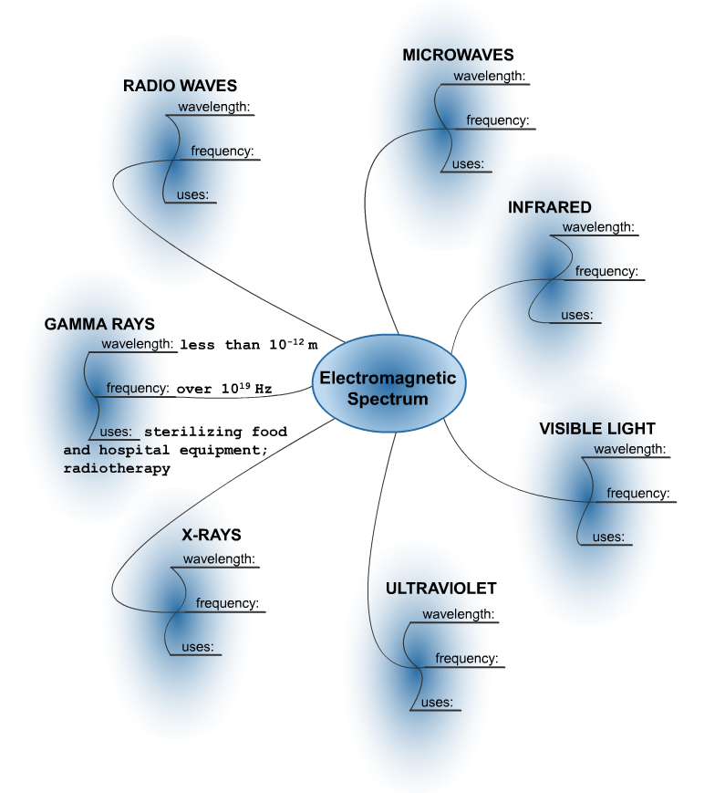
1. Complete the concept map for the EM Spectrum. Follow the example for gamma rays.

2. Write the types of radiation in order of increasing frequency:

………………………………………………………………………………………………………………
………………………………………………………………………………………………………………

