Electricity to the Home Worksheet
This worksheet accompanies Electricity Supply.ppt,
Electrical Wiring and Safety.ppt and Electrical Power.ppt

1a. Batteries produce DC. What do the letters DC stand for?

…………………………………………………………………………………………………………

b. Describe charge flow in DC circuits.

………………………………………………………………………………………………………
………………………………………………………………………………………………………
………………………………………………………………………………………………………

2. The mains supply uses alternating current (AC). Describe the charge flow in AC.

……………………………………………………………………………………………………………
……………………………………………………………………………………………………………
……………………………………………………………………………………………………………

3. Complete the diagrams below to show what you would expect to see on an oscilloscope screen for AC and DC.
AC
DC
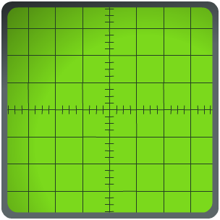

4a. Label the diagram of the three-pin plug.

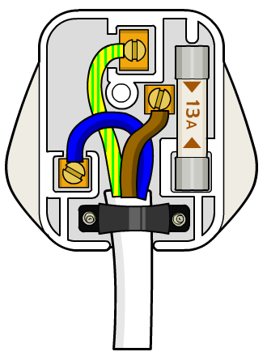

b. Complete the table to show the function of each of the key features of the plug:

feature | function

5. Fuses and circuit breakers are used as safety features in circuits.
How do these devices work?

……………………………………………………………………………………………………………
……………………………………………………………………………………………………………
…………………………………………………………………………………………………………………………………………………………………………………………………………………………
……………………………………………………………………………………………………………
6. Current heats up wires – the larger the current, the greater the heating effect.
Thin wires also heat up more than thick wires. When installing an electric cooker, should thin or thick wires be used to connect it to the mains? Explain your answer.

……………………………………………………………………………………………………………
……………………………………………………………………………………………………………
……………………………………………………………………………………………………………

7. Fuses are designed to melt and break circuits when too large a current passes through them. If a fuse is to be used in a low current circuit (when working normally), should the fuse wire be thin or thick in the plug? Explain your answer.

……………………………………………………………………………………………………………
……………………………………………………………………………………………………………
……………………………………………………………………………………………………………

8. Metal-cased appliances have a wire connected to the case. They also have a fuse in the plug. Explain what would happen if the live wire came loose and touched the case.

……………………………………………………………………………………………………………
……………………………………………………………………………………………………………
……………………………………………………………………………………………………………

9. Define power in terms of energy and time.

……………………………………………………………………………………………………………
……………………………………………………………………………………………………………
……………………………………………………………………………………………………………
10. An electric fire uses mains voltage and draws a current of 6 A.
What is its power rating? Show your working

…………………………………………………………………………………………………………
…………………………………………………………………………………………………………
…………………………………………………………………………………………………………
…………………………………………………………………………………………………………
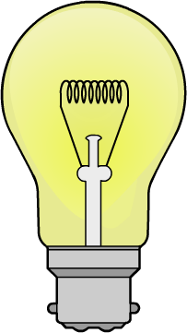

11a. A light bulb is rated at 60 W. Calculate the current through it
when it is connected to the mains and running correctly.

………………………………………………………………………………
………………………………………………………………………………
………………………………………………………………………………
………………………………………………………………………………

b. Which fuse should be fitted to the light bulb? Circle the correct answer.

1 A | 3 A | 5 A | 13 A

c. What is the energy transferred by the light bulb if it is switched on for one hour?
Show your working.

…………………………………………………………………………………………………………
…………………………………………………………………………………………………………
…………………………………………………………………………………………………………
…………………………………………………………………………………………………………

