Electricity Distribution Worksheet
This worksheet accompanies slide 22 of Electricity Distribution.ppt

1. Using the blank diagrams below, draw how direct current (DC) and alternating current (AC) would appear on an oscilloscope. Make sure to label your diagram.

direct current (DC) alternating current (DC)

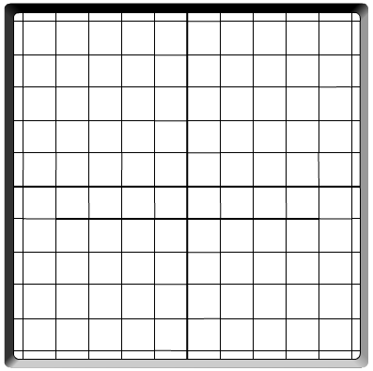

2. Describe the main differences between DC and AC, making reference to the diagrams you have drawn above.

……………………………………………………………………………………………………………
………………………………………………………………………………………………………………………………………………………………………………………………………………………………………………………………………………………………………………………………………

3. Write down two appliances that use DC and two that use AC:

appliances that use DC appliances that use AC
………………………………………..….……….. .………….…………………………………………
………………………………………..….……….. .………….…………………………………………

4. Why is AC used to supply mains electricity?

………………………………………………………………………………………………………………………………………………………………………………………………………………………………………………………………………………………………………………………………
…………………………………………………………………………………………………………
…………………………………………………………………………………………………………
…………………………………………………………………………………………………………

5. What is the voltage and frequency of AC mains electricity in the UK?

voltage: ……………………………………………
frequency: ……………………………………………

