Components in Series and Parallel Worksheet
This worksheet accompanies Series and Parallel Circuits.ppt and Circuit Components.ppt

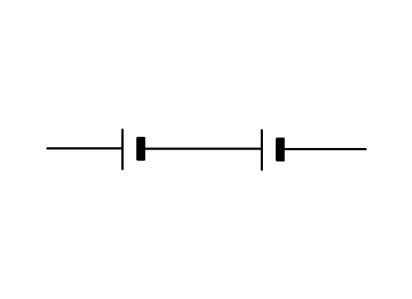
1. What is the potential difference across the following combinations of cells?
1.5 v
1.5 v
............................................................................
............................................................................
............................................................................
1.5 v
2.5 v

............................................................................

............................................................................
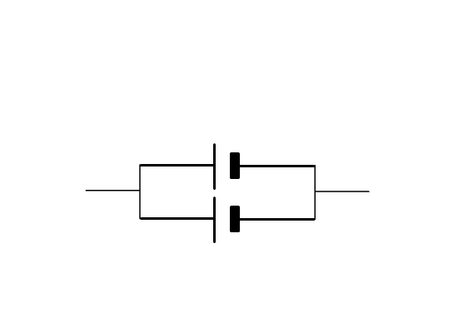
1.5 v
1.5 v
............................................................................

............................................................................
............................................................................
............................................................................

2. Describe the current at each component in a series circuit.

……………………………………………………………………………………………………………
……………………………………………………………………………………………………………
……………………………………………………………………………………………………………

3. If two identical resistors are connected in series to a 10 V supply, what is the potential
difference across each resistor?

……………………………………………………………………………………………………………
……………………………………………………………………………………………………………
……………………………………………………………………………………………………………

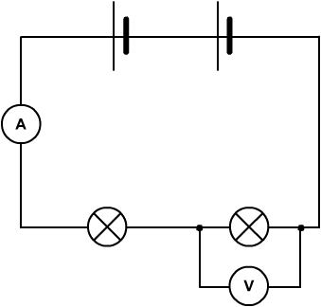
4. Study the following diagram:
A
B
1.5V
1.5V
2V
0.01A

a. What is the current at A?

…………………………………………………………………………………………………………
…………………………………………………………………………………………………………
…………………………………………………………………………………………………………

b. What is the potential difference across the bulb B?

…………………………………………………………………………………………………………
…………………………………………………………………………………………………………
…………………………………………………………………………………………………………
c. Which bulb has the greatest resistance?

…………………………………………………………………………………………………………
…………………………………………………………………………………………………………
…………………………………………………………………………………………………………

5. Describe the potential difference and current in a parallel circuit.

……………………………………………………………………………………………………………
……………………………………………………………………………………………………………
……………………………………………………………………………………………………………

6. Sketch the voltage–current graph for a filament bulb and explain its shape. Include the following words in your answer: ion lattice, electrons, heat, and collisions.

..........................................................................
..........................................................................
..........................................................................
..........................................................................
..........................................................................
..........................................................................
.........................................................................
..........................................................................
..........................................................................
.........................................................................
7. Sketch the voltage–current graph for a diode. Explain its shape.

..........................................................................
..........................................................................
..........................................................................
..........................................................................
..........................................................................
..........................................................................
.........................................................................
..........................................................................
..........................................................................
.........................................................................

8. Draw a graph showing how resistance changes for an LDR as light intensity changes.

