Communicating with Radio Waves and Microwaves Worksheet
This worksheet accompanies slide 30 of Communicating with Radio Waves and Microwaves.ppt

1. Radio ‘sky waves’ can be sent long distances using Earth’s atmosphere. On the diagram below, draw how radio waves can be sent from the radio tower in the UK to a radio tower on the other side of the Earth.

ionosphere

a. What is the range of frequencies used for radio sky waves?

…………………………………………………………………………

2. Microwaves are used for satellite communication. On the diagram below, draw how satellite signals would be sent between the two towers.
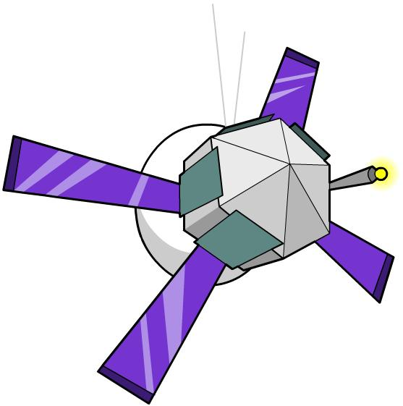
ionosphere

a. What frequencies are used for satellite communication?

…………………………………………………………………………
3a. What happens to the radio waves at the ionosphere?

……………………………………………………………………………………………………………

3b. What happen to the satellite microwaves at the ionosphere?

……………………………………………………………………………………………………………

3c. Why do radio waves and microwaves behave differently at the ionosphere?

……………………………………………………………………………………………………………
……………………………………………………………………………………………………………
……………………………………………………………………………………………………………
……………………………………………………………………………………………………………
……………………………………………………………………………………………………………

