Climate Change Worksheet
This worksheet accompanies slide 31 of Climate Change.ppt

Study the two graphs then answer the questions below.

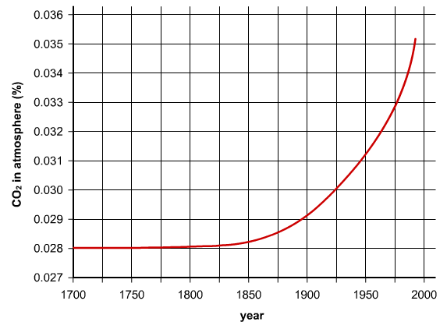

Graph 1.

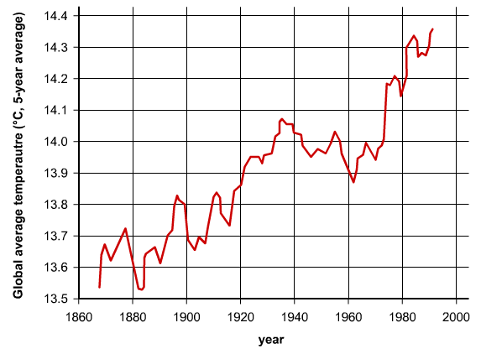

Graph 2.

- State three possible causes of the trend in graph 1.

………………………………………………………………………………………………………………………………………………………………………………………………………………………………………………………………………………………………………………………………………………………………………………………………………………………………………………………………………………………………………………………………………………………………………………………………………………………………………………………………………………

- What is the overall trend in graph 2?

…………………………………………………………………………………………………………………………………………………………………………………………………………………………

- Can you explain how the two graphs are related?

……………………………………………………………………………………………………………………………………………………………………………………………………………………………………………………………………………………………………………………………………………………………………………………………………………………………………………………

- State three gases that contribute to the greenhouse effect.

…………………………………………………………………………………………………………………………………………………………………………………………………………………………
……………………………………………………………………………………………………………

- State three ways in which the UK government could reduce greenhouse gas emissions.

………………………………………………………………………………………………………………………………………………………………………………………………………………………………………………………………………………………………………………………………………

- State three ways in which you could personally reduce greenhouse gas emissions.

………………………………………………………………………………………………………………………………………………………………………………………………………………………………………………………………………………………………………………………………………

