Analogue and Digital Signals Worksheet
This worksheet accompanies slide 18 of Analogue and Digital Signals.ppt

The image below shows an analogue signal. The signal’s current changes continuously.

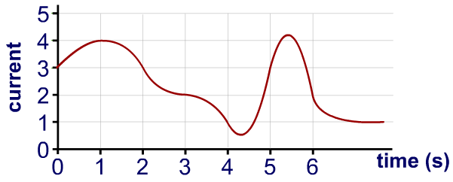

- Sample the current at one second intervals, and write down a six digit analogue code (i.e., the first digit will be ‘4’, since at 1 second the current is 4).

………………………………………………………………………………………………………………
………………………………………………………………………………………………………………
- Using the table below, convert the six digit analogue code into binary. There should be 18 ones or zeros.
Analogue | Digital
0 | 000
1 | 001
2 | 010
3 | 011
4 | 100
5 | 101

………………………………………………………………………………………………………………
………………………………………………………………………………………………………………

- Draw the digital wave that would be stored in memory, or transmitted as a signal.

