Worksheet One
This worksheet accompanies slide 4 of Grammar Activities 1.ppt

Nouns and verbs
Write a sentence about each picture on the lines.

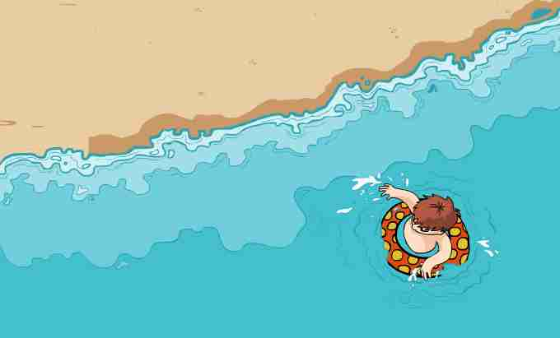
____________________________________________________________________________________________________________________________________________________________________________________

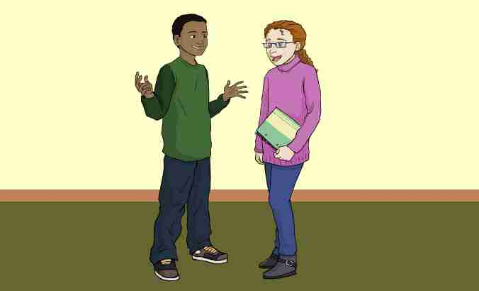
____________________________________________________________________________________________________________________________________________________________________________________

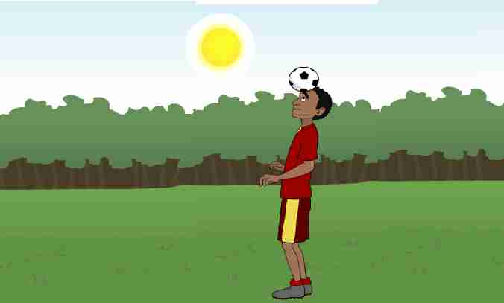
____________________________________________________________________________________________________________________________________________________________________________________

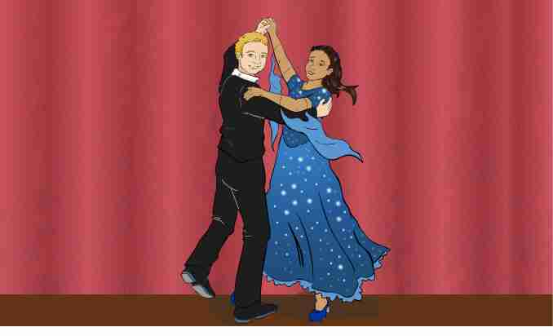
___________________________________________________________________________________________________________________________________________________________________________________

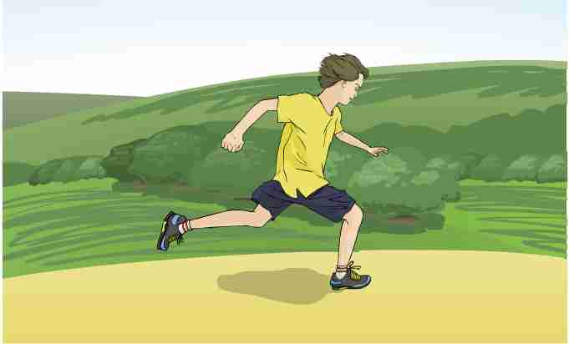
____________________________________________________________________________________________________________________________________________________________________________________

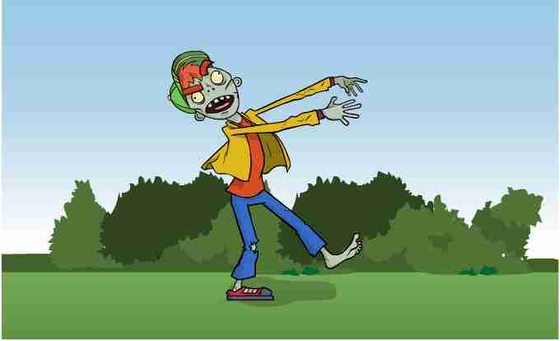
____________________________________________________________________________________________________________________________________________________________________________________

Worksheet Two
This worksheet accompanies slide 7 of Grammar Activities 1.ppt

Capitalize
Remember to use a capital letter at the beginning of sentences and when you use “I.” Circle all the letters that should be capital letters in this story about a day at the circus!

i have a dog named Sam. my family went to see the circus and we brought Sam with us.

there were clowns making balloon animals. rides with people screaming and laughing. good smells from the hotdog and cotton candy stands.

sam like the good smells the most. i liked the rides and the games. we didn’t want to leave at the end of the day. mom and Dad promised we can come back next year.

Worksheet Three
This worksheet accompanies slide 8 of Grammar Activities 1.ppt

Punctuation
Tortoise wrote a letter to his friend Hare, but he forgot the punctuation. Can you fill in the missing punctuation below? Use each type of punctuation:

!
.
?

Dear Hare,
Did you know there is a race tomorrow I may be slow but I am steady. I know I’m going to win the race I hope I’ll see you there
Sincerely,
Tortoise

