Your teacher will give you:

* sterile Petri dishes containing a layer of sterile nutrient agar jelly. These dishes have been inoculated with two different bacteria
* paper discs containing four different antibiotics
* sealing tape
* incubator at 25°C
* forceps
* Virkon disinfectant.

**1. Design an experiment**.  
Your task is to design an experiment to show how different antibiotics affect two different bacteria. Remember what you have learnt about the importance of sterilizing   
your equipment.

You will not be able to see bacteria on the agar plates now, but they have been inoculated with the bacteria. Colonies of bacteria will grow if the agar plates are placed in an incubator for 1–2 days.

You have circles of paper that contain four different antibiotics. Plan an experiment to find out which bacteria are affected by each antibiotic.

Remember the safety instructions and sterile procedures, and check your method with your teacher if you have any doubts.

**2. Carry out the experiment, and use the table overleaf to record your results**.   
Note down whether the bacteria are able to grow, or if they are inhibited by the antibiotic.   
If they are inhibited, how big is the zone of inhibition? You might also want to draw or describe what the bacteria look like.

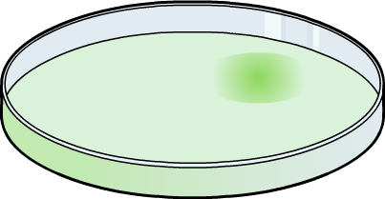

|  |  |  |
| --- | --- | --- |
|  | **bacteria one** | **bacteria two** |
| **antibiotic one =** |  |  |
| **antibiotic two =** |  |  |
| **antibiotic three =** |  |  |
| **antibiotic four =** |  |  |

**3. What can you conclude from your experiment about the resistance or susceptibility of your two bacteria to the four antibiotics?**

…………………………………………………………………………………………………………...

…………………………………………………………………………………………………………...

…………………………………………………………………………………………………………...

…………………………………………………………………………………………………………...…………………………………………………………………………………………………………..…………………………………………………………………………………………………………...

……………………………………………………………………………………………………………………………………………………………………………………………………………………