The Circulatory System Worksheet
This worksheet accompanies Circulation.ppt, The Heart.ppt and Blood.ppt

1. Answer the questions below about the different types of circulatory system.
- Draw lines to match the organism with the type of circulatory system it has.
amoeba
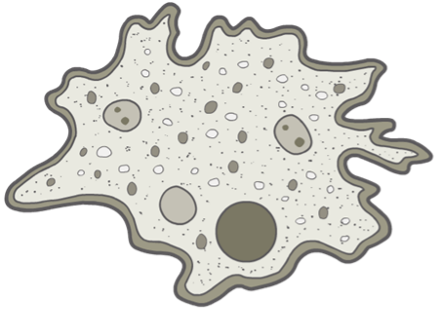
open circulatory system

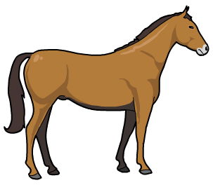
horse

no circulatory system

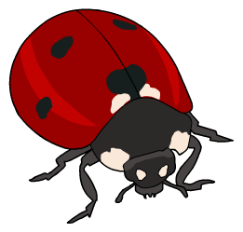
ladybird

closed circulatory system

- Organism X has a circulatory system where the fluid moves around the body cells under low pressure and is not confined to vessels. What type of circulatory system does organism X have?

…………………………………………………………………………………………………
- Decide which blood vessel each statement relates to by writing artery, capillary or vein next to it.

Blood flows through these narrow,
thin-walled vessels in organs. ………………………………

These vessels are thick and contain
muscle and elastic fibres. ………………………………

Valves prevent the back-flow of
blood in these vessels. ………………………………

Substances pass into cells from the
blood through these vessels. ………………………………

These vessels transport blood when
it is at its highest pressure. ………………………………

- Complete the following sentences about maintaining blood flow in the arteries.
Arteries can narrow due to the build-up of ………………………… on the artery wall.
This can ………………………… blood flow. Maintaining blood flow in the coronary arteries is very important because these vessels supply blood to the …………………………
An artificial tube, called a …………………………, can be used to keep the arteries open. When the tube is inserted in the correct place in the artery, it expands, widens the artery walls and restores blood flow.
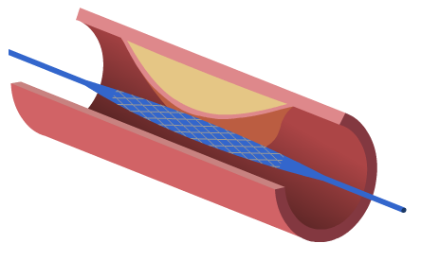
artificial tube

narrowing artery

2. Blood is a tissue and consists of a fluid called plasma in which red blood cells, white blood cells, and platelets are suspended. Answer the questions below.

a. Draw a line to match the blood component with its function

plasma clots blood at injury sites

red blood cell transports nutrients, urea, glucose, hormones and amino acids

platelet helps to fight infection

white blood cell transports oxygen

b. State two ways in which red blood cells are adapted to their function.
i. ………………………………………………………………………………………………
………………………………………………………………………………………………
………………………………………………………………………………………………
ii. ………………………………………………………………………………………………
………………………………………………………………………………………………
………………………………………………………………………………………………
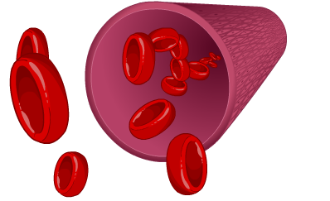

- There are different blood groups called A, B, AB and O. Following an accident, a patient may receive blood from a donor in a blood transfusion; however the donor blood and the patient blood must be compatible. Complete the table below.

Blood group | Antigen | Antibodies | Can receive this blood group
O |  | anti-A and  anti-B
A | A |  | A and O
B |  | anti-A | B and O
AB | A and B |  | all blood groups

3. Nicola has a condition in which her blood does not easily clot. She was told it runs in her family.

- What is the name of this condition?
……………………………………………………………………………………………………
- Give two symptoms that Nicola may display because of this condition.

i. ………………………………………………………………………………………………
………………………………………………………………………………………………
ii. ………………………………………………………………………………………………
………………………………………………………………………………………………

- Drugs such as warfarin and aspirin are used to control clotting. What type of drug are these?

……………………………………………………………………………………………………

4. The heart is an organ and pumps blood around the body.

- Label the structure of the heart.

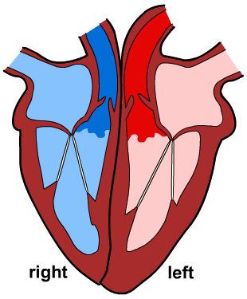

- Complete the following sentences by circling the correct word(s).

The blood enters the [ atria / ventricles ], which contract and push the blood into the
[ atria / ventricles ]. Blood flows from the heart to the organs through [ arteries / veins ], and returns through [ arteries / veins ]. In humans, there are two separate circulation systems, one for the lungs and one for all other organs of the body. This is why it is called a [ single / double / separate ] circulatory system. The contraction of the heart is controlled by groups of cells called [ electrical cells / pacer cells / pacemaker cells ], which produce [ an electric current / hormones ].

- An electrocardiograph (ECG) trace of Ahmed’s heart beat is recorded, as shown below. Answer the following questions.

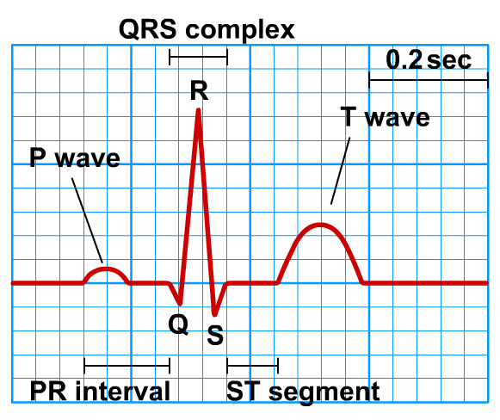

  - The P wave represents the electrical activity during atrial contraction.
Estimate the length of time of the P wave.
……………………………………………………………………………………………
  - The trace above was recorded while Ahmed was sitting down. What will happen to Ahmed’s heart rate as he exercises on an exercise bike?

……………………………………………………………………………………………

  - If ECG traces are recorded as Ahmed exercises, will the time between each QRS complex increase or decrease?

……………………………………………………………………………………………

