The Carbon Cycle Worksheet
This worksheet accompanies the presentation The Carbon Cycle.ppt

1. Fill in the gaps in the text below:

Proteins, _______ and sugar all contain carbon. Life without carbon would be very different and might be impossible.

Carbon is present in the atmosphere as _____________________.

Plants use carbon dioxide during ________________ to produce ______________. The carbon is then transferred to animals along ___________ chains.

As dead matter _______________, carbon is released back into the atmosphere in the form of carbon dioxide.

The carbon from dead organisms can also form __________ fuels and sedimentary rocks such as ________________.

2. Complete the following equation to show the process of combustion:

carbon
+
+
→
water
+
oxygen

3. List as many fossil fuels as you can think of in the space below:

4. Are the following statements true or false? Read each statement and then write down whether it is true or false in the column next to it.

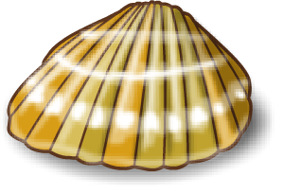
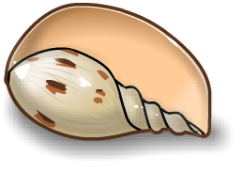
True or false?Photosynthesis is a sink for carbon.Carbon in the atmosphere is found in the form of carbon dioxide.Combustion is a very similar reaction to respiration.Respiration takes place in chloroplasts.Limestone is mostly made from the remains of dead animals.Carbon is a major component of proteins and fats.The ocean contains less carbon than the atmosphere.Fossil fuels take in carbon dioxide when they burn.Animals make their own glucosePlants may store glucose in the form of starch.

