Sustainability 2 Worksheet
This worksheet accompanies Humans and the Environment.ppt

1. Complete the following sentences about ecosystems by circling the correct word(s).

In [ a closed loop / an open end / an open loop ] ecosystem, there is no waste.
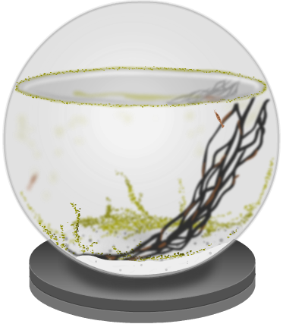
This is because the output from one part of the system
becomes the [ output / input ] for another part of the
system, as food or raw materials. For example, the
[ oxygen / carbon dioxide ] that is given out by green plants during photosynthesis is used when living things
[ excrete / ferment / respire ]. Dead, organic matter is broken down by [ sunlight / micro-organisms / pests ], which releases nutrients back into the environment.

In reality, no ecosystem is a perfect [ closed loop / open end / open loop ] system.
This is because some output is always lost: organisms may [ migrate into / migrate out ] of an area, or nutrients may be lost to the water or air. When these losses are balanced by gains from elsewhere, the ecosystem is said to be [ skewed / unsustainable / stable ].

2. Answer the following questions about the atmosphere and carbon.

- The natural carbon cycle is a closed loop system but human activity can change this. Explain why the use of crude oil does not meet the requirements of a closed loop system.

………………………………………………………………………………………………......
………………………………………………………………………………………………......
………………………………………………………………………………………………......
………………………………………………………………………………………………......
………………………………………………………………………………………………......

- Label the diagram of the carbon cycle.
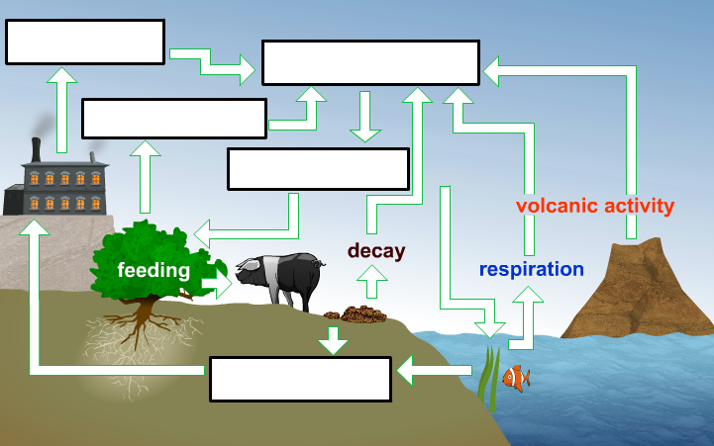

- List three human activities that may increase the levels of atmospheric carbon dioxide.

i. ………………………………………………………………………………………
………………………………………………………………………………………
………………………………………………………………………………………
ii. ………………………………………………………………………………………
………………………………………………………………………………………
………………………………………………………………………………………
iii. ………………………………………………………………………………………
………………………………………………………………………………………
………………………………………………………………………………………

- Below are two graphs. The top graph shows the change in temperate from average over time, and the bottom graph shows the change in atmospheric carbon dioxide levels over time.
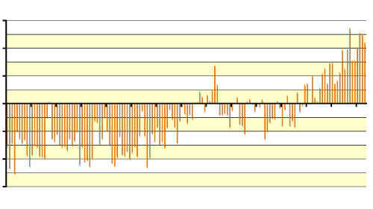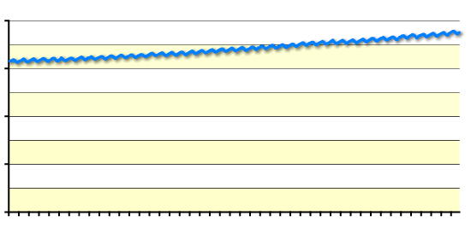
1861
2001
1941
difference from
average temp. (°C)
0.6
0
0.4
0.2
-0.2
-0.4
-0.6
year
0
400
2000
1960
1980
300
200
100
CO₂ conc. (ppm)
year
  - What does each graph suggest about the change in average global temperature and the level of atmospheric carbon dioxide?

……………………………………………………………………………………......
……………………………………………………………………………………......
……………………………………………………………………………………......
……………………………………………………………………………………......

  - Discuss whether the graphs show a causal relationship between the average global temperature and the level of atmospheric carbon dioxide.

……………………………………………………………………………………......
……………………………………………………………………………………......
……………………………………………………………………………………......
……………………………………………………………………………………......

- List four possible effects of an increase in the Earth’s temperature.

i. ……………………………………………………………………………………………
……………………………………………………………………………………………
ii. ……………………………………………………………………………………………
……………………………………………………………………………………………
iii. ……………………………………………………………………………………………
……………………………………………………………………………………………
iv. ……………………………………………………………………………………………
……………………………………………………………………………………………
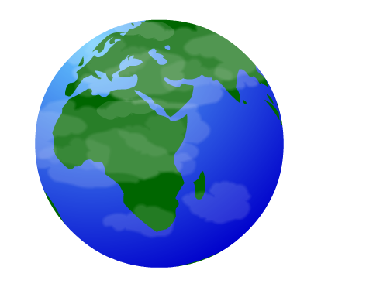

3. The removal of forest habitats to make use of the land is called deforestation. Answer the following questions.

- Vegetation, such as rainforests, can play an important role in an ecosystem.
Match each aspect of vegetation with its effect on a stable ecosystem.

plant leaves bind the soil together and reduce
soil erosion

transpiration in leaves protect the soil from direct rainfall and
reduce soil erosion

plant roots recycles water back into the atmosphere
and leads to cloud formation

- Deforestation can occur so that crops can be grown to produce biofuels.
Complete the table to compare fossil fuels and biofuels.

 | Fossil fuels | Biofuels
What are they? | limited amounts of crude oil, gas and coal; also known as  …………………… resources | includes bioethanol, produced by the fermentation of  …………………. in plants
Do they pollute the atmosphere? Explain. | Yes, they release carbon dioxide during the process of  …………………………….. | Biofuels are described as  ………………………………  because there is not net release of carbon dioxide when burned.
Give an advantage of using this fuel. | ……………………………..  …………………………….. | ……………………………..  ……………………………..
Give a disadvantage of using this fuel. | ……………………………..  …………………………….. | ……………………………..  ……………………………..

