Skeletal Systems Worksheet
This worksheet accompanies Skeletal Systems.ppt

1. Different animals have different types of skeleton. Answer the questions below.

- Draw a line to match each organism with the skeleton its body has.



internal skeleton made of
bone and some cartilage



no hard skeleton

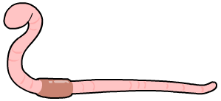

internal skeleton made
only of cartilage



external skeleton made
of chitin

- Give three advantages of an internal skeleton compared to an external skeleton.
i. ………………………………………………………………………………………
………………………………………………………………………………………
ii. ………………………………………………………………………………………
………………………………………………………………………………………
iii. ………………………………………………………………………………………
………………………………………………………………………………………

2. The diagram below shows the human arm. Answer the questions below.

- On the diagram, label the humerus, ulna, radius, biceps and triceps.
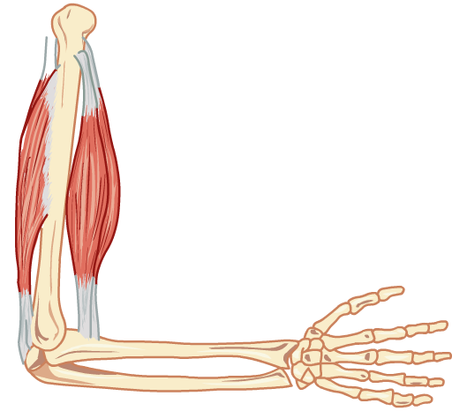

- Complete the table to explain how the arm moves.
 | bending the arm | straightening the arm
biceps muscle
triceps muscle

- What name is given to a pair of muscles which work in this way?
……………………………………………………………………………………………………

3. Answer the questions below about the different types of joint in the human body.

- Name the type of joint found at the elbow.
……………………………………………………………………………………………………

- Match each of these structures found in a joint to their function. Some functions correspond to more than one structure.

cartilage and synovial fluid holds bones together to stabilize joints
ligaments encloses a joint and produces synovial fluid
tendons reduces friction between bones
synovial membrane attach muscles to bones and transmits forces between them

- In rheumatoid arthritis, synovial fluid may become thicker. Why might this be painful?
……………………………………………………………………………………………………
……………………………………………………………………………………………………
……………………………………………………………………………………………………
4. The x-rays below show some fracture bones. Answer the questions below.

- Name each type of fracture next to the correct image.
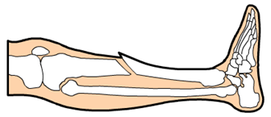

......................................................
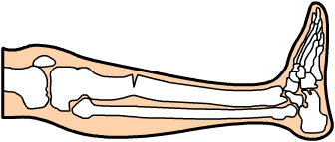

......................................................
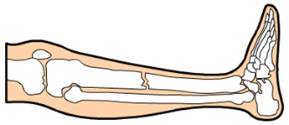

......................................................

- Saul hurts his ankle playing tennis. He goes to the hospital for an x-ray. There is no fracture, but the nurse says he has sprained it. What treatment would she advise him to carry out for his sprain?

……………………………………………………………………………………………………
……………………………………………………………………………………………………
……………………………………………………………………………………………………
……………………………………………………………………………………………………
- Maria falls over in the street. Her x-ray shows she has a fractured hip and tests show that Maria has a low bone density. What might the doctor conclude?

……………………………………………………………………………………………………
……………………………………………………………………………………………………

