Respiration and Circulation Worksheet
This worksheet accompanies Respiration.ppt and Anaerobic Respiration.ppt.

1. The table below compares aerobic and anaerobic respiration. Tick the boxes that apply to each type of respiration. You can tick neither, one, or both boxes on
each row.

 | Aerobic respiration | Anaerobic respiration
Releases energy from glucose.
Requires oxygen.
Requires sunlight.
Takes place in cells at all times.
Takes place in cells when oxygen levels are low.
Produces lactic acid in animals.
Produces ethanol in yeast.
Is controlled by enzymes.
Takes place mainly in the mitochondria.
Takes place in humans during strenuous exercise.

2. Complete the following equations for aerobic respiration. Balance the symbol equation if necessary.

……………… + oxygen carbon dioxide + ………………+ energy

C₆H₁₂O₆ + …..… ……CO₂ + ……H₂O + energy

3. Organisms respire to release energy from food.

a) Give 3 uses that mammals might have for this energy.

1 ................................................................................................................................................
2 ................................................................................................................................................
3 ................................................................................................................................................
b) List three molecules which plants might convert glucose into.

1 ................................................................................................................................................
2 ................................................................................................................................................
3 ................................................................................................................................................
4. A student decides to investigate aerobic respiration by measuring his pulse and breathing rate before and after a 20 minute walk. The results are shown below.

 | heart rate (beats/min) | breathing rate (breaths/min)
before walk | 70 | 14
immediately after walk | 82 | 20

Explain why these changes take place.

...................................................................................................................................................
...................................................................................................................................................
...................................................................................................................................................
...................................................................................................................................................

5. Another student decides to investigate anaerobic respiration. He uses a pulse monitor to record his pulse rate during a ten minute run, and then for 10 minutes afterwards. His results are shown in the table below.

a) Plot a graph of these results.
time (minutes) | pulse rate  (beats per minute)
0 | 65
1 | 78
2 | 91
3 | 102
4 | 122
5 | 143
6 | 139
7 | 138
8 | 140
9 | 145
10 | 144
11 | 140
12 | 138
13 | 122
14 | 114
15 | 103
16 | 95
17 | 83
18 | 70
19 | 65
20 | 65
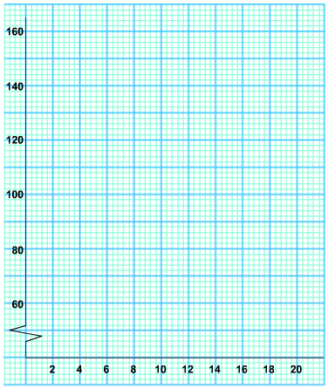

pulse rate (beats per minute)

time (minutes)
b) Explain why the student’s pulse rate did not return to normal immediately after exercise.

................................................................................................................................................
................................................................................................................................................
................................................................................................................................................
................................................................................................................................................
................................................................................................................................................
................................................................................................................................................

c) Give two disadvantages of anaerobic respiration compared to aerobic respiration.

................................................................................................................................................
................................................................................................................................................

d) Write the word equation for anaerobic respiration in humans.

..............................................................................................................................................

6. a) Write the word equation for anaerobic respiration in yeast.

..............................................................................................................................................

b) List two examples of commercial uses of this reaction.

..............................................................................................................................................
..............................................................................................................................................
7. Draw lines to match the components of blood to their functions.

red blood cell
causes the blood to clot to prevent loss

platelets
medium in which substances float or dissolve

white blood cell
fight invading pathogens

plasma
carry oxygen

8. Fill in the gaps in the passage below.
The circulatory system ………………… substances around the body.
Blood vessels called ………………… have thick muscular walls and transport blood away from the ………………… to other tissues and organs.
Blood is taken from tissues to the heart by blood vessels called …………………, which have larger lumens and thin walls.
………………… are small vessels which exchange materials with tissues.

9. a) Label the diagram below.
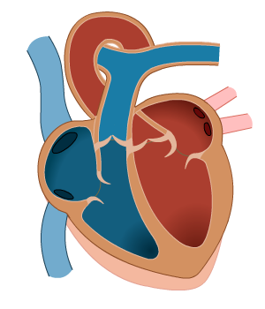

……………………… ………………………

……………………… ………………………

……………………… ………………………

……………………… ………………………

………………………

b) Complete the table below using the names of some of the labelled parts of the heart.

Receives deoxygenated blood from the vena cava.
Prevents backflow into the ventricles
Blood vessel which carries blood out of the heart to the rest of the body.
Blood vessel which carries blood out of the heart to the lungs.
Chamber of the heart with the thickest muscle wall.

