Reflex Reactions Worksheet
This worksheet accompanies slide 8 of Reflex Reactions.ppt

1. The diagram below shows a reflex arc for a knee-jerk reflex.
Label the following:
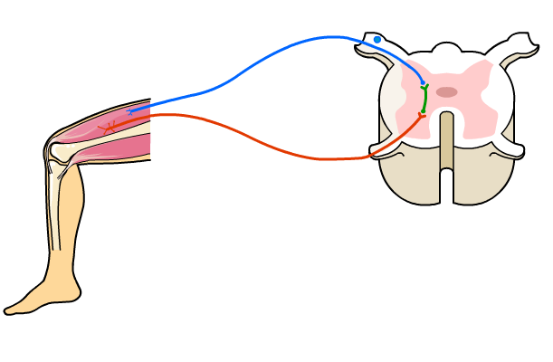
- sensory neurone
- relay neurone
- motor neurone
- effector
- receptor.

2. Complete the table below showing some receptors and effectors involved in
common reflexes. The first row has been completed for you.

Reflex | Receptor | Effector
knee-jerk | stretch receptors in thigh | thigh muscle
pupil reflex to bright light
mouth watering at the smell of food
dropping a hot plate

