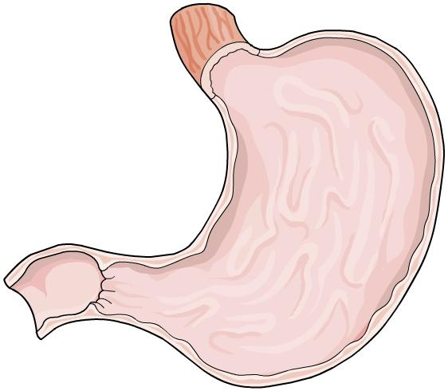
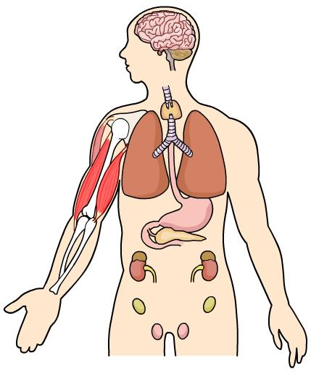
Organ Systems Worksheet
To accompany The Digestive System.ppt and Multicellular Organisms.ppt

- Describe the difference between unicellular and multicellular organisms.

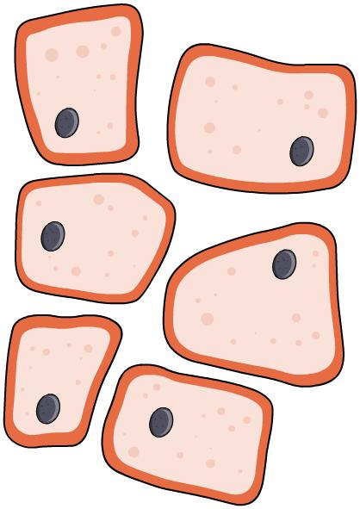
………………………………………………………………………………………………………………………………………………………………………………………………………………………………………………………………………………………………………………………………………

- Describe two advantages of being multicellular.

………………………………………………………………………………………………………………………………………………………………………………………………………………………………………………………………………………………………………………………………………
- Multicellular organisms contain groups of specialized cells which are adapted to
carry out specific functions. These combine to make organs and organ systems.
Explain why the development of specialized organ systems might be important for multicellular organisms.

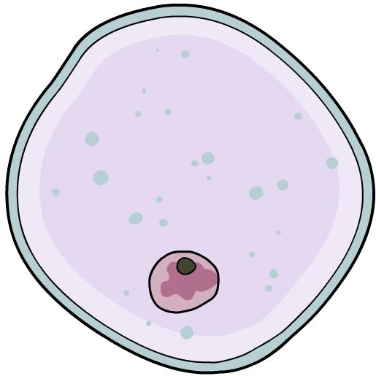
………………………………………………………………………………………………………………………………………………………………………………………………………………………………………………………………………………………………………………………………………………………………………………………………………………………………………………………………………………………………………………………………………………………………………………………………………………………………………………………………………………

- Complete the following sentences:

- All multicellular organisms begin as …………………….….…
- Differentiation is a process by which……………….…………………………………………….
……………………………………………………………………………………………………………
c) Cell division is a process by which…………………………………………………………….…
…..………………………...…………………………………………………………………………

- Write a definition for each of these words and describe what they are
made up of:

- Cell

………………………………………………………………………………………………………………………………………………………………………………………………………………

- Tissue

………………………………………………………………………………………………………………………………………………………………………………………………………………
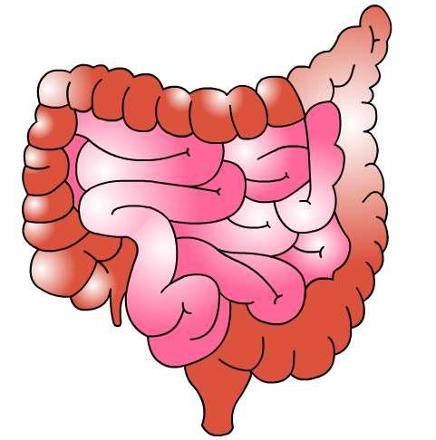
i) Give one example of a type of tissue and describe its function in the body.
………………………………………………………………………………………………

- Organ
……………………………………………………………………………………………………………………………………………………………………………………………………………….
i) Give one example of a type of organ and describe its function in the body.
………………………………………………………………………………………….
- Organ system
..............................................................................................................................
..............................................................................................................................

- The stomach is an organ that contains three types of specialized tissue.
Write the function of each tissue next to its name:

- Muscular tissue…………………………………………………………………………………….. ……………………………………………………………………………………………................
- Glandular tissue……………………………………………………………………………………. ……………………………………………………………………………………………………….
- Epithelial tissue……………………………………………………………………………………..
……………………………………………………………………………………...........................

- The digestive system is one example of a system through which humans and other mammals exchange substances with the surrounding environment. Label the organs of the digestive system on the diagram below.
………………......
………………......
………………......
………………......
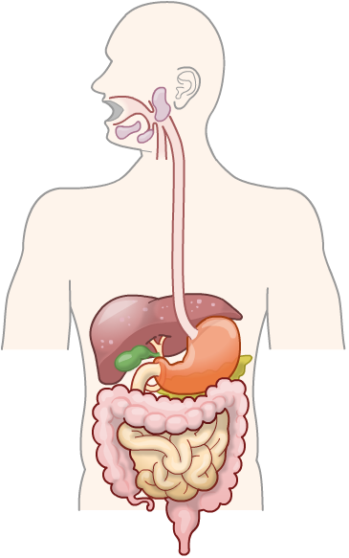
………………......
………………......
………………......
………………......
- Give another example of an organ system that helps to exchange substances with
the environment.

……………………………………………………………………………………………………...…
- Describe the function of the pancreas in the digestive process.

…………………………………………………………………………………………………..……………………………………………………………………………………………………………..………
pancreas liver stomach oesophagus small intestine large intestine gall bladder salivary glands
  - Fill in the gaps in these sentences about the digestive system:
The digestive system includes glands such as the …………………
And salivary glands which produce ………………… juices.
The digestive system is made up of the following:
    - the stomach and …………………, where digestion occurs
    - the liver, which produces …………………
    - the small intestine, where the ………………… of soluble food occurs
    - the large intestine, where water is absorbed from the undigested food, producing ………………….

absorption faeces digestive bile small intestine pancreas

  - Explain three ways in which the small intestine is adapted to speed up the diffusion of digested food molecules into the blood stream.

....………………………………………………………………………………………………………..………………………………………………………………………………………..……………………………………………………………………………………………………………………………………………………………………………………………………………………………………

  - It is claimed that Probiotics like Bifidobacteria can reduce levels of
low-density cholesterol in the blood. Explain one way this could be tested
and evaluate the validity of any potential results.

…………………………………………………………………………………………………………………………………………………………………………………………………………………………………………………………………………………………………………………………………………………………………………………………………………………………………………
…………………………………………………………………………………………………………
…………………………………………………………………………………………………………
…………………………………………………………………………………………………………

