Nutrients Worksheet
This worksheet accompanies the presentation Nutrients.ppt

1. Fill in the gaps in the passage below.

Proteins are made up of chains of ……………… ………………. .
We need to eat protein every day because our bodies can’t ……………….… it. We can turn protein into energy if our energy supplies are low, but it is usually used for …………………..… and ……………….….….
Some people might need more protein than others. Examples of people who need more protein than average include ……………….….… and ……………….….….

- A person’s EAR of protein can be calculated using the equation:

protein (g) = 0.6 × body mass (kg)

a) What does EAR stand for?
…………………………………………………..…………………………

b) Calculate the EAR of protein for a person weighing 72kg.
………………………………………………………….………………….
…………………………………………………………….……………….
……………………………………………………………….…………….

……………………………………………………….…………………….

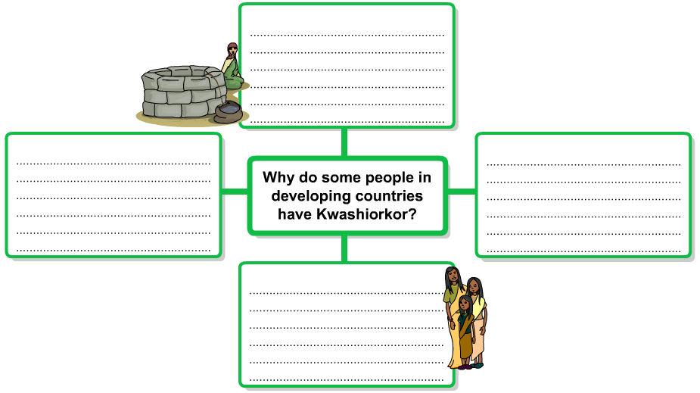
3. Fill in this chart with some of the reasons why people in developing countries are more likely to suffer from Kwashiorkor.
environmental factors
economic factors
social factors
political factors

