Mitosis Worksheet
This worksheet accompanies the presentation Mitosis.ppt.

1. a) A student prepares some root tip squashes to show the stages of mitosis.
He makes drawings of the various stages, but gets them in the wrong order. Number the images to show the correct order.

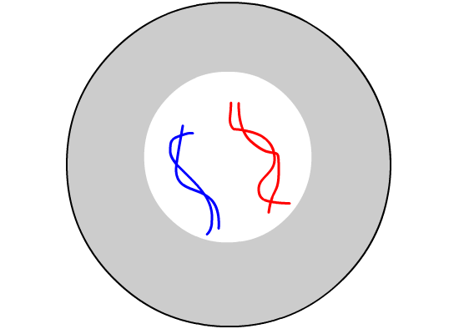
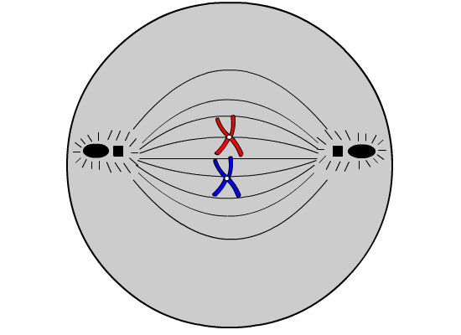

.............. ..............

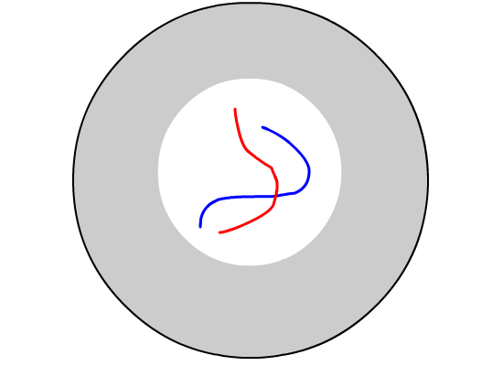
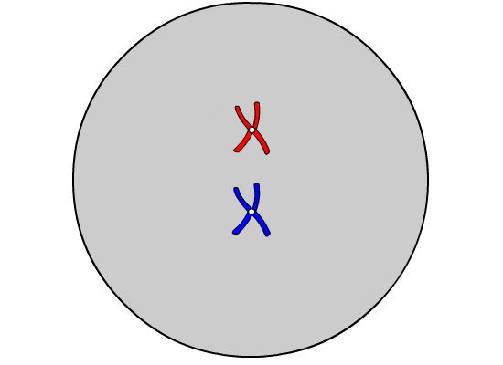

.............. ..............
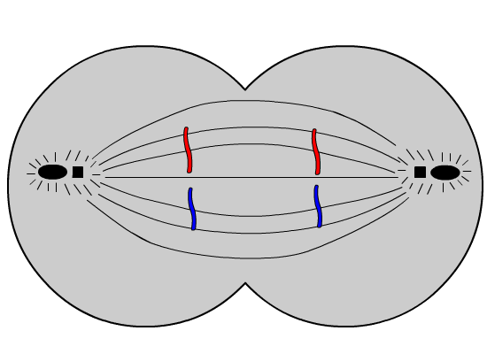

..............
b) Number these statements from one to nine to show the correct order of the different stages.

chromosomes divide ...................

complementary bases pair up to form new double strands of DNA ...................

chromosomes line up along the centre of the cell ...................

the copied chromosomes move to opposite poles of the cell ...................

DNA ‘unzips’ to form single strands ...................

DNA shortens and condenses and the replicated chromosomes
become clear in the nucleus …………….

nuclear envelopes form around two new nuclei ...................

the cell divides to form two identical daughter cells ...................

the nuclear envelope disappears …………….

2. Cross out a word or words to make the sentences below correct.

Mitosis produces two / four identical daughter cells.

Cells produced by mitosis are diploid / haploid.

Daughter cells are exact / similar copies of the original cell.

Mitosis is used to produce sex / body cells.

In body cells, chromosomes are normally found alone / in pairs.

Before mitosis, the chromosomes / nuclear envelopes are copied.

Mitosis can be observed by preparing squashes of sperm / root tips.

