Meiosis and Stem Cells Worksheet
This worksheet accompanies Meiosis and Reproduction.ppt and Stem Cells.ppt

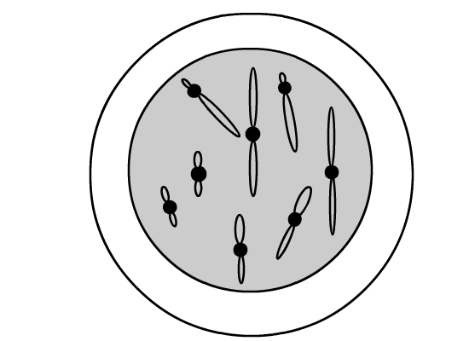
1. Scientists discover a new species of animal.
It has eight chromosomes in each body cell and
reproduces sexually. One of its body cells is
shown here:

a) What is the diploid number for this animal?

……………………………………………………………

b) What is the haploid number for this animal?

……………………………………………………………

c) How many sets of chromosomes will be found in one of its gametes?

……………………………………………………………………………………………………………

The animal produces gametes by the process of meiosis. The diagrams below show
the process.

d) Draw in the missing chromosomes at each stage using the information from
the boxes.

Stage 1 Stage 2
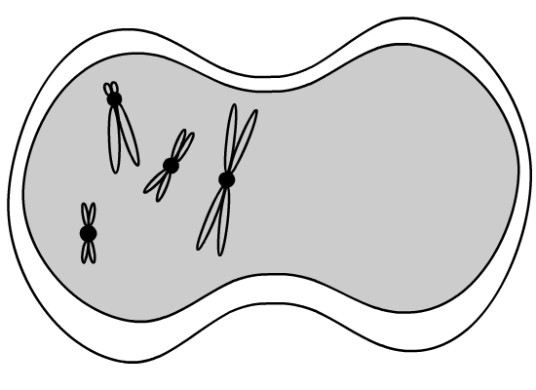
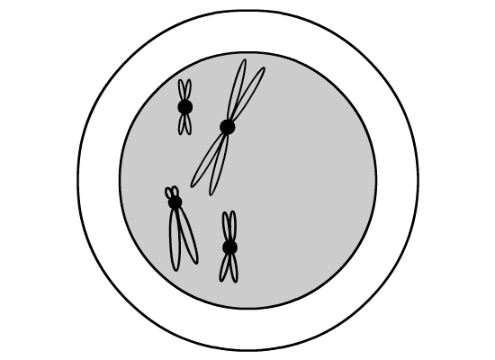

The chromosomes make an exact copy  of themselves. | The chromosomes split up into two cells.  Each cell has one of each pair of  homologous chromosomes.

Stage 3 Stage 4

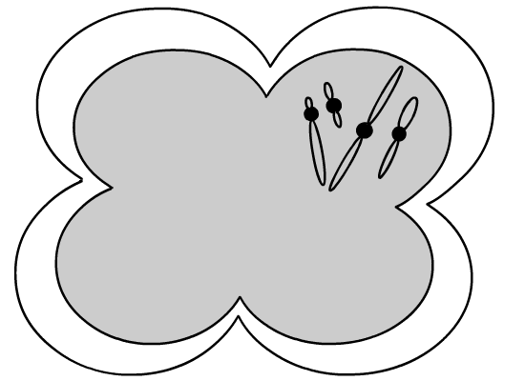
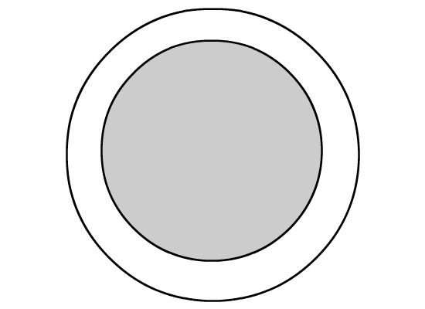

The chromosomes are then pulled apart to form four cells. | Each sex cell produced has half of the original number of chromosomes.

e) Why is it so important for the number of chromosomes in a sex cell to be half that of a normal body cell?

……………………………………………………………………………………………………………
……………………………………………………………………………………………………………
……………………………………………………………………………………………………………

2. Variations occur during sexual reproduction. This variation is important to the process of evolution. Explain how variation occurs during meiosis and fertilization.

………………………………………………………………………………………………………………

………………………………………………………………………………………………………………

………………………………………………………………………………………………………………

………………………………………………………………………………………………………………

………………………………………………………………………………………………………………

………………………………………………………………………………………………………………

3. The questions below are about stem cells.

a) Where are stem cells found? Underline the correct answers.

embryos adult blood adult bone marrow egg cells

b) Mark which of the following statements are true and which are false.
True/False

(i) Stem cells can be made to develop into different types of cell. ...................

(ii) Adult stem cells can be made to differentiate into every type of cell. ...................

(iii) Stem cells are unspecialised cells. ...................

(iv) Most cells keep the ability to differentiate as they mature. ...................

(v) Human embryo cells are all identical until there are eight of them. ...................

6. In 1995, Christopher Reeve, the American actor best-known for playing Superman, was paralysed in an accident. He became a huge campaigner in favour of stem cell research. Unfortunately, he died before any great breakthroughs were made.
Since then, trials have started to investigate whether embryonic stem cells can repair nerve damage in people who have been paralysed.
Part of the reason for the delay was that the previous US president, George Bush, had banned research using embryonic stem cells because he thought it was wrong. In the UK, stem cell research can only be carried out with permission from the Human Fertilisation and Embryo Authority, on embryos developed from eggs fertilized outside the body.

a) Why do scientists think that stem cells might be useful in helping people
with paralysis?

………………………………………………………………………………………………………
………………………………………………………………………………………………………
………………………………………………………………………………………………………
b) Where do most human embryonic stem cells used for research in the UK
come from?

………………………………………………………………………………………………………
………………………………………………………………………………………………………
………………………………………………………………………………………………………

c) Why do some people object to embryonic stem cell research?

………………………………………………………………………………………………………
………………………………………………………………………………………………………
………………………………………………………………………………………………………
………………………………………………………………………………………………………
………………………………………………………………………………………………………

d) In the UK, the Human Fertilisation and Embryo Authority make decisions on which stem cell experiments are allowed. Who do you think should be responsible for setting the regulations for this research? (E.g. the public, politicians, religious leaders, scientists, etc.) Explain your answer.

………………………………………………………………………………………………………
………………………………………………………………………………………………………
………………………………………………………………………………………………………
………………………………………………………………………………………………………
………………………………………………………………………………………………………
………………………………………………………………………………………………………
………………………………………………………………………………………………………
………………………………………………………………………………………………………
………………………………………………………………………………………………………
………………………………………………………………………………………………………

