Measuring Environmental Change Worksheet
This worksheet accompanies the presentation Measuring Environmental Change.ppt

1. What is an indicator species?
………………………………………………………………………………………………………………
………………………………………………………………………………………………………………
2. Read each statement carefully and then tick the box to show whether you think that it is true or false.

statement | true | false
A pollutant is a substance that contaminants water.
Nitrates are a type of water pollution.
Using indicator species to monitor pollution needs specialist equipment.
The type and number of lichen can be used as an indicator of air pollution.
The type of vertebrate animals in a stream can be used as an indication of water pollution.
Sulfur dioxide is a type of air pollution.
Eutrophication can increase the oxygen level in a river.
Phytoplankton grows better in water polluted by nitrates.
3. Look at the graph below and use it to answer the questions that follow.
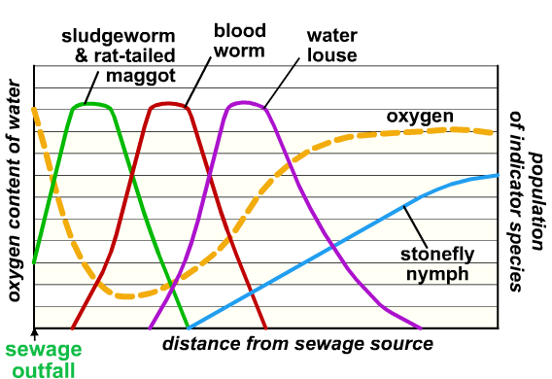

- What is the independent variable?

……………………………………………………………………………………………………………
- What happens to the oxygen content of the water when the sewage is added?

……………………………………………………………………………………………………………
……………………………………………………………………………………………………………
- Which species can live in water with low oxygen levels? Circle two answers.

  - Sludgeworm and rat-tailed maggot
  - Blood worm
  - Water louse
  - Stonefly nymph

- Which species can only live where oxygen levels are high? Circle one answer.

  - Sludgeworm and rat-tailed maggot
  - Blood worm
  - Water louse
  - Stonefly nymph
4. Instruments can be used to collect data about an ecosystem.
a) What is a data logger?
……………………………………………………………………………………………………………
……………………………………………………………………………………………………………

b) What are the advantages of using a temperature data logger rather than a
thermometer?
……………………………………………………………………………………………………………
……………………………………………………………………………………………………………
……………………………………………………………………………………………………………
……………………………………………………………………………………………………………
……………………………………………………………………………………………………………
……………………………………………………………………………………………………………

c) What are the advantages of using indicator species rather than oxygen sensors
and data loggers?
……………………………………………………………………………………………………………
……………………………………………………………………………………………………………
……………………………………………………………………………………………………………
……………………………………………………………………………………………………………





