Interdependence Worksheet
This worksheet accompanies slide 15 of Interdependence.ppt

Look at the woodland food web below, and then answer the following questions:

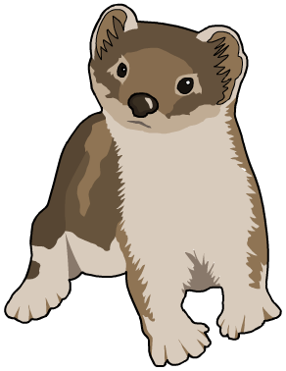
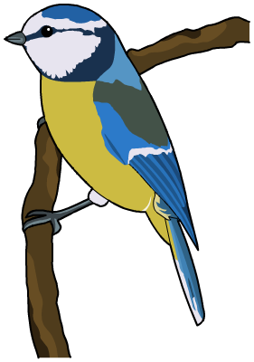
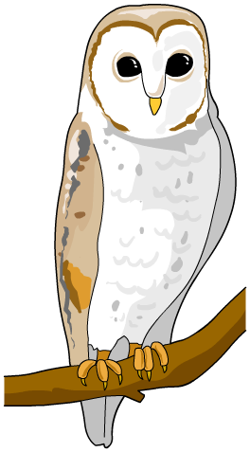
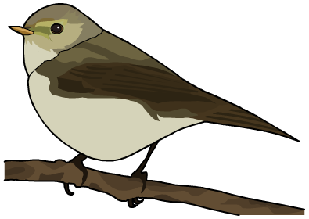
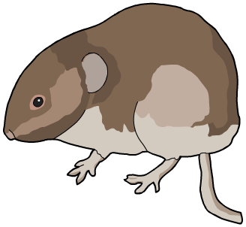
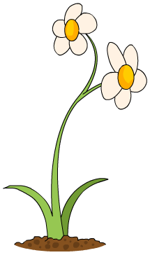
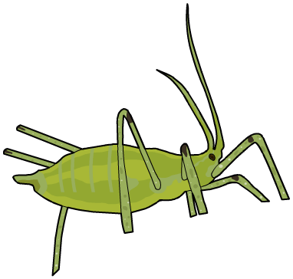
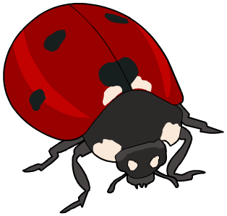
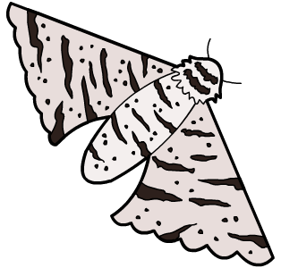
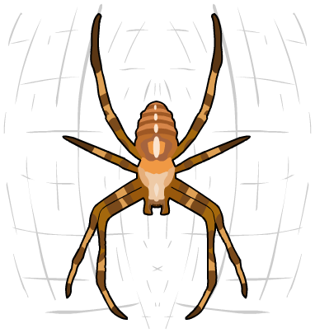
aphid
owl
finch
spider
moth

stoat

bluetit

vole

ladybird

plant

1. Name the producer in this food web.

……………………………………………………………………………………………………………

2. Name two herbivores in this food web.

……………………………………………………………………………………………………………

3. Name two species that are top carnivores.

……………………………………………………………………………………………………………
4. How many secondary consumers are there?

……………………………………………………………………………………………………………
5. Which food chains include the moth?

…………………………………………………………………………………………………………………………………………………………………………………………………………………………
……………………………………………………………………………………………………………
6. Human activity has resulted in the number of plants in the woodland becoming reduced. What will happen to the numbers of other organisms in this food web?

……………………………………………………………………………………………………………
……………………………………………………………………………………………………………
……………………………………………………………………………………………………………
……………………………………………………………………………………………………………
……………………………………………………………………………………………………………
……………………………………………………………………………………………………………

7. The graph below shows the number of owls over the next 10 years. Draw a line to show the number of secondary consumers you would expect:

