
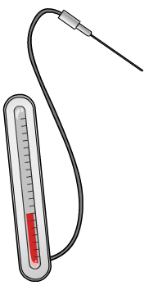
Inherited Disorders Worksheet
This worksheet accompanies Inherited Disorders.ppt

1. Some people at risk of having children with genetic disorders choose to have IVF
treatment, and have the embryos tested for the condition before they are implanted. This is called Pre-implantation Genetic Diagnosis (PGD) and embryo selection. The Human Fertilisation and Embryology Authority must agree that a particular genetic condition is sufficiently serious before clinics are permitted to test embryos for that condition.

Carry out some research to investigate the ethics and regulations associated with genetic information and genetic testing. The following websites are good starting points.

http://www.hfea.gov.uk
http://www.ukgtn.nhs.uk/gtn/Home

2. Read the case studies below and imagine that you were part of the HFEA committee.
Would you allow embryo selection in these cases?

a) Paul and Sarah have decided to have a child. Sarah is 45 and so the chances of her children having a genetic condition are higher than for younger women. They want to have PGD to test for Down’s syndrome.

b) Kai has Beta Thalassaemia, which can be very dangerous. One of his best chances for
survival is a transfusion of stem cells from a tissue-matched donor. In order to guarantee a match, his parents Jay and Fatima would have to conceive another child by IVF and use pre-implantation tests to select embryos that are a tissue match to Kai but do not have the disease. The stem cells from the new child would then be able to save Kai.
c) Pat is colour blind. All his life he has found it inconvenient. Pat and Shelly are talking about having children, and Pat wants to use PGD to select embryos that do not have the colour-blindness allele.

d) Derek and Shaina are both carriers of the allele responsible for causing cystic fibrosis. They want to use PGD to select an embryo that does not carry the cystic fibrosis allele to ensure that their child will not have the disease.

These weblinks were working correctly at the time of publication. Boardworks takes no responsibility for the content of external web pages.

