Inheritance Worksheet
This worksheet accompanies Inheritance.ppt

1. The gene for normal ears in rabbits (E) is dominant over the gene for large floppy ‘lop ears’ (e). Represent the following genotypes using letters:

a) homozygous dominant ………………………………

b) homozygous recessive ………………………………

c) heterozygous ………………………………

2. Ben has a pet rabbit with normal ears.

a) What possible genotypes could his rabbit have for the gene relating to ears?

………………………………………………………………………………………………………………
b) Describe how Ben could establish the genotype of his rabbit by breeding it with other rabbits.

………………………………………………………………………………………………………………
………………………………………………………………………………………………………………
………………………………………………………………………………………………………………
………………………………………………………………………………………………………………
………………………………………………………………………………………………………………

3. A homozygous lop-eared rabbit was crossed with a heterozygous normal eared rabbit. Over 2 years, they produced 12 offspring. How many of the offspring would you expect to have lop ears? Show your working.

………………………………………………………………………………………………………………
………………………………………………………………………………………………………………
………………………………………………………………………………………………………………
………………………………………………………………………………………………………………
rabbit A
rabbit C
rabbit B
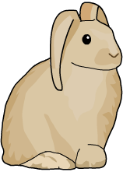
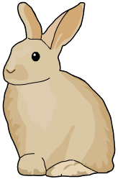

EE

4. Identify the genotypes of:

a) rabbit A ………………………………

b) rabbit B ………………………………

c) rabbit C ………………………………

5. Draw a Punnett Square for
the cross between rabbit A
and rabbit B.

