Growth and Mitosis Worksheet
This worksheet accompanies Plant and Animal Growth.ppt and Mitosis.ppt.

- Sam is six years old and his parents are worried that he is not growing properly.
Their doctor explains that percentile charts like the one below are often used to check if children are growing properly.
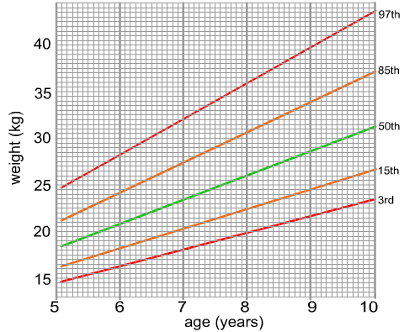
Weight-for-age BOYS

percentiles

a) Sam weighs 18kg. Which percentile does this put him at? Explain what this means.

………………………………………………………………………………………………………
………………………………………………………………………………………………………
The doctor says there is nothing to worry about yet, but he wants to monitor how well Sam grows over the next year. He weighs Sam every three months and records the results below.

age | weight (kg)
6 years 3 months | 19
6 years 6 months | 19.1
6 years 9 months | 19.7
7 years | 20.5

c) Plot these results on the graph above.

d) Do you think the doctor would be worried about Sam’s growth?

………………………………………………………………………………………………………
………………………………………………………………………………………………………
2. Plant growth can be measured as an increase in height, dry mass or wet mass.
What are the advantages and disadvantages of these methods of measurement?

……………………………………………………………………………………………………………

……………………………………………………………………………………………………………

……………………………………………………………………………………………………………

……………………………………………………………………………………………………………

……………………………………………………………………………………………………………

……………………………………………………………………………………………………………

……………………………………………………………………………………………………………

……………………………………………………………………………………………………………

……………………………………………………………………………………………………………

3. The statements below refer to growth in either animals or plants. Tick boxes in each row to show which refer to plants, which refer to animals and which refer to both.

 | Plants | Animals
grow continuously
grow at specific stages in life
grow to a finite size
grow mainly in special areas called meristems
most cells lose the ability to differentiate at an
early stage
many cells remain able to differentiate throughout life
all parts of the organism are involved in growth
cell division in mature organisms is mainly for replacing cells and repair

4. a) A student prepares some root tip squashes to show the stages of mitosis.
He makes drawings of the various stages, but gets them in the wrong order. Number the images to show the correct order.
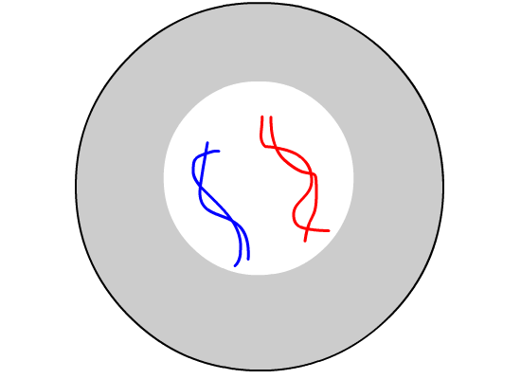
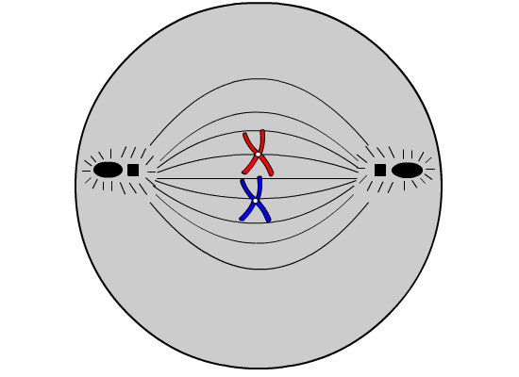

.............. ..............
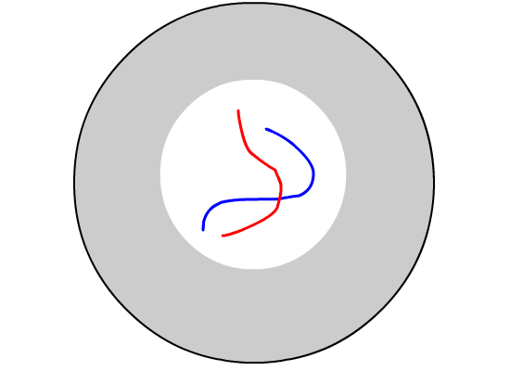
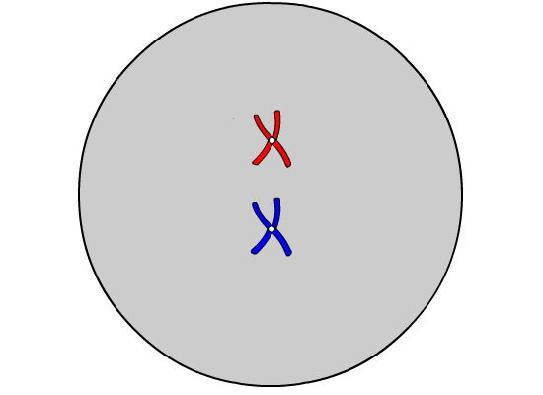

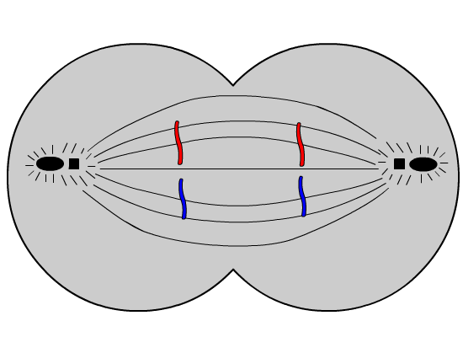
.............. ..............

..............
b) Number these statements from one to nine to show the correct order of the different stages.

chromosomes divide ...................

complementary bases pair up to form new double strands of DNA ...................

chromosomes line up along the centre of the cell ...................

the copied chromosomes move to opposite poles of the cell ...................

DNA ‘unzips’ to form single strands ...................

DNA shortens and condenses and the replicated chromosomes
become clear in the nucleus …………….

nuclear envelopes form around two new nuclei ...................

the cell divides to form two identical daughter cells ...................

the nuclear envelope disappears …………….

5. Cross out a word or words to make the sentences below correct.

Mitosis produces two / four identical daughter cells.

Cells produced by mitosis are diploid / haploid.

Daughter cells are exact / similar copies of the original cell.

Mitosis is used to produce sex / body cells.

In body cells, chromosomes are normally found alone / in pairs.

Before mitosis, the chromosomes / nuclear envelopes are copied.

Mitosis can be observed by preparing squashes of sperm / root tips.

