Food Production Worksheet
This worksheet accompanies Food Production.ppt and Micro-organisms in Food Production.ppt

1. Explain how human population growth affects the amount of food we need to produce.

…………………………………………………………………………………………………………
…………………………………………………………………………………………………………
…………………………………………………………………………………………………………

2. The diagram below shows a simple food web.

human

cereals

cow

a. Draw the food chain shown in this web which shows the most efficient use of the energy from the cereal.
…………………………………………………………………………………………………………

b. Where did the cereals get their energy from?
…………………………………………………………………………………………………………
c. Priti thinks her vegetarian diet is an efficient use of world resources. Explain why she thinks this.
…………………………………………………………………………………………………………
…………………………………………………………………………………………………………
…………………………………………………………………………………………………………
…………………………………………………………………………………………………………
…………………………………………………………………………………………………………

d. Dave has a diet of intensively reared meat and fish. He thinks this is an efficient way of producing food. Explain why he thinks this.
…………………………………………………………………………………………………………
…………………………………………………………………………………………………………
…………………………………………………………………………………………………………
…………………………………………………………………………………………………………
…………………………………………………………………………………………………………


e. Complete this table giving arguments for and against factory farming of hens.

For | Against

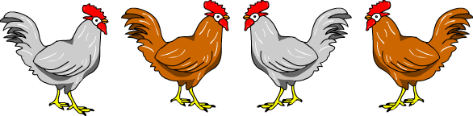
3. The graphs below give information about fish stocks.
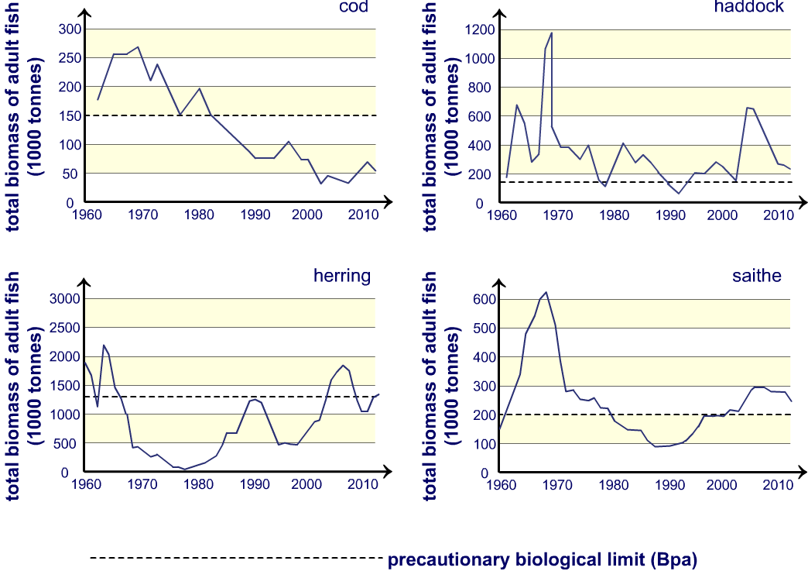

a. What do you notice about the stocks of these 4 fish in 1990?
…………………………………………………………………………………………………………

b. Which would be a sustainable fish to eat in 2012? Explain your answer.
…………………………………………………………………………………………………………
…………………………………………………………………………………………………………
…………………………………………………………………………………………………………
c. What measures can be taken to conserve fish stocks?
…………………………………………………………………………………………………………
…………………………………………………………………………………………………………
…………………………………………………………………………………………………………
4. Genetic modification is another way in which the efficiency of food production might be increased.

a. List three advantages genetically modified crops have over normal ones.
i.…………………………………………………………… ………………………………
………………………………………………………………………………………………
ii.…………………………………………………………… ………………………………
………………………………………………………………………………………………
iii.…………………………………………………………… ………………………………
………………………………………………………………………………………………

b. List three potential problems with genetically modified food.
i.…………………………………………………………… ………………………………
………………………………………………………………………………………………
ii.…………………………………………………………… ………………………………
………………………………………………………………………………………………
iii.…………………………………………………………… ………………………………
………………………………………………………………………………………………

