Excretion Worksheet
This worksheet accompanies Excretion.ppt and Kidney Failure.ppt

1. Complete the following sentences about excretion.

Excretion and egestion are two different processes. The removal of undigested food is known as …………………………, whilst the removal of waste products made by the body is known as…………………………. Waste products, made by metabolic reactions, must be removed as their build up can be …………………………

Carbon dioxide is produced by a process called ………………………… and removed from the ………………………… by breathing out. The liver produces ………………………… when excess ………………………… acids are broken down. The ………………………… remove it from the blood and form urine, which is temporarily stored in the ………………………… before being released from the body.

2. Urine is made by the kidneys. Answer the questions below.
- Arrange these stages of urine formation into the correct order.
Add the numbers 1 to 4 next to the statement to identify the order.

Some of the filtered water and ions are reabsorbed. The amount
which is reabsorbed depends on the needs of the body.

All the filtered glucose is reabsorbed into the blood.

The remaining filtrate forms urine and is stored in the bladder.

Blood is filtered at high pressure. Liquid and dissolved substances
pass into the kidney tubule, but blood cells remain in the blood vessel.
- The diagram shows a labelled nephron. Match the process with the correct place at which this occurs by drawing a line between them.

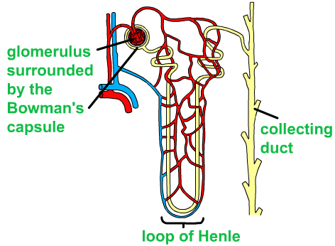

reabsorption of water controlled by the hormone, ADH
reabsorption of substances including glucose and ions
ultrafiltration of
the blood

3. Answer the following questions about urine.

- The urine samples described below were collected from different people.
Fill in the table with the options below to match the urine sample to the person
it was collected from.

A A person with kidney damage
B A long distance runner after a marathon
C A person who drinks a lot of water on a cold day
D A person with diabetes

Description of the urine sample | Who the urine was collected from
a dark sample, low in volume
a sample containing glucose
a pale sample, high in volume
a pink sample, containing protein

- How will the amount of water lost in urine change on a hot day? Explain why.
……………………………………………………………………………………………......
……………………………………………………………………………………………......
……………………………………………………………………………………………......
……………………………………………………………………………………………......

- Outline the role of anti-diuretic hormone (ADH) in controlling water loss.
……………………………………………………………………………………………......
……………………………………………………………………………………………......
……………………………………………………………………………………………......
……………………………………………………………………………………………......
……………………………………………………………………………………………......
……………………………………………………………………………………………......
4. Doctors use the table below to determine if people have kidney disease, and if so at what stage it is. Answer these questions about kidney disease.

Stage | Glomerular filtration rate (GFR) | Comments
- | Above 90 | Normal kidney function
1 | 90 | Normal kidney function, however check urine sample and structure of kidney that could point to kidney disease
2 | 60–89 | Mildly reduced kidney function
3 | 30–59 | Moderately reduced kidney function
4 | 15–29 | Severely reduced kidney function
5 | <15 | Very severe, or established kidney failure

- A doctor suspects that one of her patients has kidney disease. She carries out tests and finds that the patient’s glomerular filtration rate (GFR) is 86. What should the doctor conclude and advise?

…………………………………………………………………………………………….......
…………………………………………………………………………………………….......
…………………………………………………………………………………………….......
…………………………………………………………………………………………….......

- Look at the table and decide what values you would you expect the glomerular filtration rate (GFR) to be for someone who requires dialysis?

………………………………………………………………………………………………...

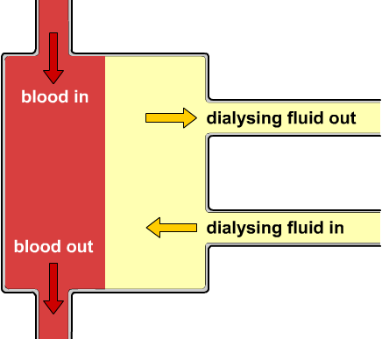

- If of the kidneys fail, the patient might be treated with dialysis. Answer whether these statements about dialysis are true or false by circling the correct answer.

Treatment by dialysis raises the
concentrations of dissolved substances
in the blood above normal levels. True False

Dialysis only has to be carried out once. True False

In a dialysis machine a person’s blood
flows through impermeable membranes. True False

The dialysis fluid contains a greater
concentration of useful substances
than the blood. True False

Dialysis removes sodium and maintains
levels of urea and glucose in the blood of
a patient with kidney failure. True False

5. A man offered his kidney on the internet to raise money for his sick daughter.
He was offered £80,000 by a patient waiting for a kidney transplant. Answer the questions below.

- What are the advantages and disadvantages of kidney transplants?

…………………………………………………………………………………………….......
…………………………………………………………………………………………….......
…………………………………………………………………………………………….......
…………………………………………………………………………………………….......
…………………………………………………………………………………………….......
…………………………………………………………………………………………….......
…………………………………………………………………………………………….......
…………………………………………………………………………………………….......
…………………………………………………………………………………………….......

- The man selling his kidney was told he was breaking the law and the sale was prevented. Do you think selling organs should be allowed?

…………………………………………………………………………………………….......
…………………………………………………………………………………………….......
…………………………………………………………………………………………….......
…………………………………………………………………………………………….......
…………………………………………………………………………………………….......
…………………………………………………………………………………………….......



