Environmental Change and its Effects Worksheet
This worksheet accompanies Environmental Change and its Effects.ppt

1. What is meant by an “endangered species”?
………………………………………………………………………………………………………………
2. Read this article about the Dhole and answer the questions that follow.
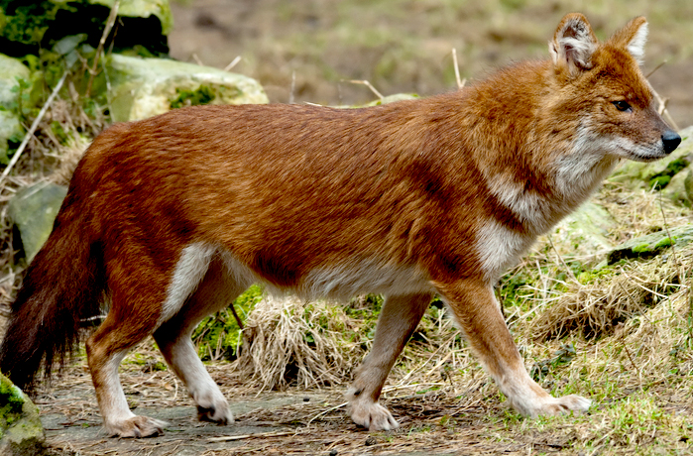
The decline of the dhole

The dhole, or Asiatic wild dog, is
one of the most endangered
predators in the world. In 2008
the International Union for
Conservation of Nature (IUCN)
estimated that there were less
than 2,500 adult dholes left in
the wild and that their decline
looked set to continue.

Dholes have historically lived all over South East Asia, but their territories are now much smaller and more fragmented. This is largely due to destruction of suitable habitats as roads and human habitation encroach on wild areas. Populations of deer, wild boar and other prey animals have also declined rapidly over the last 40 years due to habitat destruction and hunting. Free-roaming domestic dogs may also be competing with the dhole for prey, as well as transmitting diseases such as mange and canine distemper.

As dhole habitats decrease, they are increasingly brought into contact with humans and dhole attacks on livestock have been recorded. This has led to persecution of the dhole in some areas, for example the government of Bhutan encouraged poisoning of dholes in the 1970s, and dholes continue to be trapped or poisoned by local farmers in parts of India.

Dholes are now protected in law from human hunting in most countries where they live, but there are few other measures in place to protect them.

Photo: © 2011 (Eric Gevaert), Shutterstock.com

a) Fill in the table below to show the environmental changes that are affecting the dhole.

Changes caused by living factors | Changes caused by non-living factors

b) What organisms are competing with the dhole?

………………………………………………………………………………………………………………
………………………………………………………………………………………………………………
c) Why are restrictions on killing dholes not preventing the dhole declining?

………………………………………………………………………………………………………………
………………………………………………………………………………………………………………
………………………………………………………………………………………………………………
………………………………………………………………………………………………………………
d) If the dhole becomes extinct, what effect might this have on its ecosystem?

………………………………………………………………………………………………………………
………………………………………………………………………………………………………………
………………………………………………………………………………………………………………
………………………………………………………………………………………………………………
………………………………………………………………………………………………………………

