Disease Worksheet
This worksheet accompanies Pathogens and Disease.ppt

1. Micro-organisms that cause harm or disease are called pathogens.
Answer the following questions about pathogens.

- Give the type of micro-organism that can cause cholera and food poisoning.

……………………………………………………………………………………………

- Give the type of micro-organism that can cause influenza and chickenpox.

……………………………………………………………………………………………

- Match up how pathogens can be transmitted by drawing a line to the correct example.
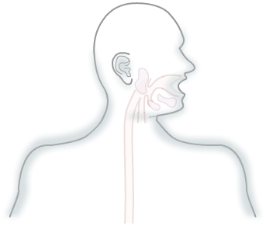
nose insect bites or cuts

skin contaminated food or water

mouth airborne micro-organisms

- Complete the following sentences about the stages of an infectious disease.

Pathogens enter the body and ……………………… rapidly. The growth of a population of bacteria in the body is called …………………………… The body provides a suitable environment for bacteria to growth – the temperature can be described as the …………………….. temperature. The appearance of symptoms
of an infectious disease can be due to the number of bacteria or because of the ………………. that they produce.
- Explain why natural disasters, such as an earthquake, can increase the incidence of an infectious disease.

…………………………………………………………………………………………………
…………………………………………………………………………………………………
…………………………………………………………………………………………………
…………………………………………………………………………………………………
…………………………………………………………………………………………………

2. Complete the table below that outlines the work of three scientists in the treatment of disease.

Scientist | Outline of their work
Louis  Pasteur | ………………………………………………………………………….  ………………………………………………………………………….  ………………………………………………………………………….
……………… | He discovered penicillin. Penicillin is an antibiotic used  to treat many bacterial infections.
Joseph  Lister | ………………………………………………………………………….  ………………………………………………………………………….  ………………………………………………………………………….

3. Lisette develops a bacterial infection. The doctor tells Lisette to complete the whole course of her antibiotics. This is because some strains of bacteria can develop antibiotic resistance by natural selection.

- Define the key terms.
antibiotic ……………………………………………………………………………
……………………………………………………………………………
……………………………………………………………………………

antibiotic resistance ……………………………………………………………………………
……………………………………………………………………………
……………………………………………………………………………
……………………………………………………………………………

natural selection ……………………………………………………………………………
……………………………………………………………………………
……………………………………………………………………………
……………………………………………………………………………

- Lisette asks the doctor why she is has been given antibiotics rather than a vaccine. Suggest what the doctor would say.








